**INTELLIGENT HOME CONTROL HUB FOR MODERN LIVING**

G.Maathushan – UWU/BET/18/011

A. Anotharsan – UWU/BET/18/025 A.Praveen – UWU/BET/18/060

S.Kishalan – UWU/BET/18/052

**DEPARTMENT OF ENGINEERING TECHNOLOGY FACULTY OF TECHNOLOGICAL STUDIES UVA WELLASSA UNIVERSITY OF SRI LANKA**

2023

**INTELLIGENT HOME CONTROL HUB FOR MODERN LIVING**

In partial fulfilment of the requirement for the Degree of Bachelor of

Engineering Technology Honors in Mechanical Engineering

G.Maathushan – UWU/BET/18/011

A. Anotharsan – UWU/BET/18/025

S.Kishalan – UWU/BET/18/052 A.Praveen – UWU/BET/18/060

Supervised By

Eng. S.D.R. Lakmal

Department Of Engineering Technology

Co-Supervised By

Eng. H.G.C.R. Laksiri

Department Of Engineering Technology

DEPARTMENT OF ENGINEERING TECHNOLOGY

FACULTY OF TECHNOLOGICAL STUDIES

UVA WELLASSA UNIVERSITY OF SRI LANKA

2023

**DECLARATION**

We hereby declare that the research presented in this dissertation was conducted solely under the guidance of Eng. S.D.R. Lakmal, Lecturer (Probationary), Department of Engineering Technology, Faculty of Technological Studies. Additionally, we received co-supervision from Eng. H.G.C.R. Laksiri, Lecturer (Probationary), Department of Engineering Technology, Faculty of Technological Studies. This dissertation details the outcomes of our independent project, with proper references provided wherever necessary. We confirm that no portion of this dissertation has been previously submitted or concurrently presented for any other degree.

**Group No: [FYP - 14]**

S.Kishalan – A. Anotharsan –

G.Maathushan – A.Praveen –

**CERTIFICATION**

The above canditates have carried out the project work reported in this dissertation under my/our supervision

…………….……... ……………………….

Eng. S.D.R. Lakmal, Eng. H.G.C.R. Laksiri,

Lecturer (Probationary), Lecturer (Probationary),

Department of Engineering Department of Engineering

Technology, Technology,

Faculty of Technological Studies, Faculty of Technological Studies,

Uva Wellassa University Uva Wellassa University

Sri Lanka. Sri Lanka.

**ACKNOWLEDGEMENT**

First and foremost, we would like to express our gratitude and appreciation to all those who gave us the possibility to complete this report special thanks are due to our supervisors Eng. S.D.R. Lakmal and Co-supervisor Eng. H.G.C.R. Laksiri whose help, stimulating suggestions and encouragement helped us in all time of fabrication process and on writing this report. We also sincerely thanks for the time spent proofreading and correcting our many mistakes. They provided us unflinching encouragement and support in various ways, to inspire and enrich our growth as a student and a researcher.

We also owe our sincere thanks to the Dean of the Faculty Prof. K.B. Wijesekara, Head of the Department Dr. [Eng]. H.M.C.M. Herath and all the lecturers who were supported and shared their valuable suggestions, which were very fruitful for shaping up our ideas and research. We are extremely grateful to our parents deserve special mention for their love, prayers, caring and sacrifices for educating and preparing our future. We were fortunate in having our parents and they supported us financially and gave valuable advice to execute this research.

Furthermore, we are indebted to many of our colleagues and relations who have supported us by providing research sources and ideas for this research and make our study with great success. And also, we would like to thank everybody who was important to the successful realization of the thesis, as well as expressing the apology that I could not mention personally one by one.

Thank you.

**ABSTRACT**

A smart home controller, refers to a residence equipped with advanced controller devices and automation systems that enhance convenience, efficiency and security for its occupants. The purpose of a smart home controller is to integrate various technologies and systems to create an intelligent living environment. The objectives are to maximize the security system of home, to protect the life and things from fire and other hazardous accidents, to increase the energy efficiency by automated devices and controlling devices by node red database and to monitor the functions of electronic devices in smart phones. It aims to enhance residents'' comfort, convenience, energy efficiency, and safety through automation and connectivity. Smart home controllers incorporate a range of features, including: Home automation, Connectivity, Sensors and actuators, Energy management, Security and safety. A smart home controller using the ESP8266 and ESP32 board. The controller incorporates various components such as an electronic locker, backup battery, motion detecting sensor, soil moisture sensor, MQ2 gas sensor, and a buzzer. The ESP32 and ESP8266 board acts as the facilitating connectivity and communication between these components. The system operates by detecting inputs from the sensors, monitoring the environment, and executing predefined actions based on the gathered data. The abstract provides an overview of the components and their roles in enabling smart functionality within a home setting. The use of a Node MCU board as a smart home controller, along with electronic components several benefits for a smart home. A smart home controller unit with features like a smart door, gas leakage detection, a smart control system, and an antitheft alarm offers enhanced security, convenience, safety monitoring, and energy efficiency. It allows homeowners to control access to their home, detect gas leaks, monitor their health of the home. These features transform homes into intelligent, connected spaces that improve the quality of life and simplify daily routines.

**Keywords:** IOT; NODEMCU; NODEMCU DATABASE; DC MOTORS.

**TABLE OF CONTENTS**

**CHAPTER 1** 1

1.2 Chapter Introduction 1

1.3 Background of the Smart home controller Project 1

1.4 Problems Identification 3

1.5 Research Problems 3

1.6 Aim of the Project 4

1.7 Objectives of the Project 5

1.8 Thesis Layout 5

1.9 Chapter Summery 6

**CHAPTER 2** 7

2.1 Chapter Introduction 7

2.2 Overview Smart Home Control 7

2.3 Evolution of the Intelligent Home Control Hub 8

2.4 Wireless Communication 9

2.5 A Smart Door System 9

2.6. Automated irrigation system 10

2.7.Smart Gas Leak Detecting System with Auto exhaust 11

2.8.Smart Lighting, fan and power outlet controlling System 11

2.9.Hazard detection, protection and Smart Security System 13

2.10. Energy Meter with data collecting and monitoring system 13

**CHAPTER 3** 15

3.1 Chapter Introduction 15

3.2 Materials 15

3.2.1 Hardware Component 15

3.2.2 Software Component 27

3.3 Methods 31

3.3.1 Auto Irrigation System 32

3.3.2 Single Axis Solar Tracking and Power Backup System 34

3.3.3 Smart Gas Leak Detecting and Exhaust System 35

3.3.4 Smart Water tank monitoring and Supplying System 36

3.3.5 Smart Lighting, fan and power outlet controlling System 37

3.3.6 Hazard detection, protection and Smart Security System 38

3.3.7 Energy Meter with data collecting and monitoring system 39

**CHAPTER 4** 42

4.1 Chapter Introduction 42

4.2 Result and Discussion 42

**CHAPTER 5** 49

5.1 CONCLUSIONS 49

5.2 RECOMMENDATIONS 51

REFERENCES 52

APPENDICES 55

**LIST OF FIGURES**

Figure 1:Smart home controlling Method .................................................................... 4

Figure 2: ESP8266 NODEMCU Board ..................................................................... 15

Figure 3 : Ultra-Sonic Sensor ..................................................................................... 16

Figure 4:MQ-2 sensor ................................................................................................ 16

Figure 5 : PIR (Passive Infrared) motion sensor ........................................................ 17

Figure 6: Soil Moisture Sensor .................................................................................. 17

Figure 7: Relay module .............................................................................................. 18

Figure 8: Two pin Buzzer .......................................................................................... 18

Figure 9: Set of Light Emitting Diodes ...................................................................... 19

Figure 10 : Toggle Switch .......................................................................................... 19

Figure 11: 12V Solenoid valve - 1/2" ........................................................................ 20

Figure 12: Brass Solenoid valve ................................................................................ 20

Figure 13: Dialog 4G Router...................................................................................... 20

Figure 14: 12V Gear Motor........................................................................................ 21

Figure 15: Jumper Cables .......................................................................................... 21

Figure 16:12V Electric door lock ............................................................................... 22

Figure 17: 3.2.1.15 Light-Dependent Resistor (LDR) ............................................... 22

Figure 18 : 12V electronic lock .................................................................................. 23

Figure 19 : IC - TDA2822 .......................................................................................... 23

Figure 20 : Resistors 100om, 1k, 10k ........................................................................ 24

Figure 21: 12V water pump ....................................................................................... 24

Figure 22 : I2C LED display ...................................................................................... 25

Figure 23 : Sunk box and cover ................................................................................. 25

Figure 24: Solar panel ................................................................................................ 26

Figure 25 : SCT-013 Current Sensor ......................................................................... 26

Figure 26: ZMPT101B AC Single Phase Voltage Sensor ......................................... 27

Figure 27: Arduino LOGO ......................................................................................... 27

Figure 28: node red Data Sever Diagram ................................................................... 28

Figure 29 : MQTT server working principle ............................................................. 29

Figure 30:Circuit diagram of Auto irrigator .............................................................. 33

Figure 31: Solar Tracker circuit diagram ................................................................... 34

Figure 32: Gas detector circuit diagram ..................................................................... 35 Figure 33: Water level indicator circuit diagram ....................................................... 36

Figure 34: Smart device controller circuit diagram ................................................... 37

Figure 35: Motion detector circuit diagram ............................................................... 39

Figure 36 : Energy Meter circuit diagram .................................................................. 40

Figure 37 : WIFI controlled socket outlet .................................................................. 42

Figure 38 :Portable Gas Detector & Inside parts ....................................................... 43

Figure 39: Portable Motion Detector & Inside parts .................................................. 44

Figure 40 : blender 3D model home front 01 ............................................................. 55

Figure 41: blender 3D model home side 02 ............................................................... 55

Figure 42 : blender 3D model top -03 ........................................................................ 56

`Figure 43 : blender 3D model home front -04 .......................................................... 56

Figure 44 : blender 3D model home -05 .................................................................... 57

Figure 45 : blender 3D model home -06 .................................................................... 57

Figure 46: MQTT web server Arduino code.............................................................. 58

Figure 47 : Motion detector Arduino code 01 ............................................................ 59

Figure 48 : Motion detector Arduino code 02 ............................................................ 59

Figure 49 : Motion detector Arduino code 03 ............................................................ 60

Figure 50 : Motion detector Arduino code 04 ............................................................ 60

Figure 51 : Motion detector Arduino code 05 ............................................................ 61

Figure 52 : Gas leakage and auto exhaust system Arduino code 01 .......................... 61

Figure 53 : Gas leakage and auto exhaust system Arduino code 02 .......................... 62

Figure 54 : Gas leakage and auto exhaust system Arduino code 03 .......................... 62

Figure 55 : Gas leakage and auto exhaust system Arduino code 04 .......................... 63

Figure 56 : Automated water level monitoring and filling system Arduino code 01 63

Figure 57 : Automated water level monitoring and filling system Arduino code 02 64

Figure 58 : Automated water level monitoring and filling system Arduino code 03 64

Figure 59 : Automated water level monitoring and filling system Arduino code 04 65

Figure 60 : Automated water level monitoring and filling system Arduino code 05 65

Figure 61 : Automated water level monitoring and filling system Arduino code 06 66

Figure 62 : Auto irrigation system Arduino code 01 ................................................. 66

Figure 63 : Auto irrigation system Arduino code 02 ................................................. 67

Figure 64 : Auto irrigation system Arduino code 03 ................................................. 67

Figure 65 : Wi-Fi controlled 4 channel relay Arduino code 01 ................................. 68

Figure 66 : Wi-Fi controlled 4 channel relay Arduino code 02 ................................. 68 Figure 67 : Wi-Fi controlled 4 channel relay Arduino code 03 ................................. 69

Figure 68 : Wi-Fi controlled 4 channel relay Arduino code 04 ................................. 69

Figure 69 : Wi-Fi controlled 4 channel relay Arduino code 05 ................................. 70

Figure 70 : Wi-Fi controlled 4 channel relay Arduino code 06 ................................. 70

Figure 71 : Energy meter Arduino code 01 ................................................................ 71

Figure 72 : Energy meter Arduino code 02 ................................................................ 71

Figure 73 : Energy meter Arduino code 03 ................................................................ 71

Figure 74 : Energy meter Arduino code 04 ................................................................ 72

Figure 75 : Energy meter Arduino code 05 ................................................................ 72

Figure 76 : NODE RED WEB INTERFACE ............................................................ 73

Figure 77 : NODERED DASHBOARD .................................................................... 73

**LIST O F TABLES**

Table 1: Specifications of Solenoid Valve ................................................................. 74

Table 2 : Specification of Ultrasonic Sensor.............................................................. 74

Table 3 : specification of ZMPT101B AC single phase voltage sensor .................... 74

Table 4 : specification pf SCT-013 current sensor..................................................... 75

Table 5 : specification of 12VDC Gear motor ........................................................... 75

Table 6: specification of soil moisture sensor ............................................................ 75

**LIST OF ABBREVIATIONS**

IOT - Internet of Things.

SHC -Smart home controller

PIR- Passive Infrared Sensor.

WMS- Water Management System.

LPG- Liquid petroleum gas.

PCA- Principal Component Analysis.

IR- infrared radiation.

SSL- solid-state lighting.

LED- Light-Emitting Diodes.

USB- Universal Serial Bus.

IDE- Integrated Development Environment.

# CHAPTER 1

## INTRODUCTION

#### 1.2 Chapter Introduction

The purpose of this chapter to discuss the background of the study which technologies to develop, focusing on the technologies employed in smart homes controller. Additionally, we will explore how smart home controller operate and examine both the advantages and disadvantages of their usage. Moreover, we will investigate the reasons behind the increasing popularity of smart homes in recent times. Subsequently, we will identify the research problem and the existing research gap, and outline the approach we take to address the problem effectively. Furthermore, we will outline the research objectives and explain the overall structure of the thesis, which has been carefully constructed to conduct this research comprehensively.

## 1.3 Background of the Smart home controller Project

Smart homes have emerged as a revolutionary concept, offering advanced automation and connectivity to homeowners. The integration of intelligent technologies within household environments has ushered in a plethora of advantages such as heightened convenience, optimized energy usage, bolstered security, and cost-effectiveness. Nevertheless, as the embrace of smart home solutions continues to expand, apprehensions regarding security vulnerabilities, financial implications, and operational effectiveness have surfaced. In light of these considerations, this context outlines the Smart Home Controller initiative, striving to tackle these issues and establish an economical, user-centric, adaptable, and reliable smart home framework.

* **Security Concerns in Smart houses:**

Security is a paramount concern in smart home systems, especially in the context of smart door lock (Norarzemi.,2020). Highlights the importance of focusing on security implementations in smart door locks to prevent unauthorized access and potential breaches.

* **Integration of monitoring database in Smart Home Controller Systems** The use of database and interface to manage and control smart home systems has become prevalent due to the widespread use of smartphones. (Mowad et al.,2014) points out that most smart home systems are constructed around an Android apps and web servers that provides users with a remote interface for home appliances and automation. However, as discovered, there are security vulnerabilities in some Android applications, requiring careful analysis and improvements to ensure user privacy and data protection.

* **Advantages of Smart Homes controller:**

Modern smart home designs offer several advantages, such as enhanced energy efficiency, environment-friendliness, and improved quality of life. Smart homes utilize innovative technologies, including motion sensing and the Internet of Things (IoT), to enhance comfort, security, and energy efficiency (Gaikwad et al., 2015). The integration of these technologies enables homeowners to remotely control and monitor appliances, security systems.

* **Challenges and Research Goals:**

Despite the advantages of smart homes, there are still challenges to overcome, including high costs, limited functionality, and usability issues. This research project aims to address these drawbacks and create a prototype for a low-cost, user-friendly, scalable, and reliable smart home system. The goal is to develop cutting-edge automatic systems for lighting, water appliances, security, gas leak detection, and other functionalities using the ESP8266 Node MCU and mobile phone.

The Smart home controller project seeks to enhance the implementation of security measures in smart door locks and leverage the capabilities of IoT to create an efficient, secure, and user-friendly smart home system. By addressing security concerns and providing cost-effective solutions, the SHC project aims to promote the widespread adoption of smart homes and contribute to the improvement of modern lifestyle and living standards.

## 1.4 Problems Identification

Despite rapid advancements in the industry, smart home technology has not yet become widely adopted by businesses. This can be attributed to several factors, including high pricing, installation and usage difficulties, limited capabilities and lack of customization. When crafting a smart home solution, it's essential to factor in various key elements. Firstly, the system should be reasonably priced and accessible to attract more consumers. Secondly, it needs to be scalable, allowing easy integration of new devices as technology evolves. Lastly, a user-friendly interface is crucial on the host side to enable simple control and monitoring of connected devices.

Smartphones play a pivotal role in wireless data transmission, utilizing technologies like Bluetooth and Wi-Fi to communicate with other devices. Lately, mobile apps have played a pivotal role in driving advancements within the realm of smart home technology. The implementation of new technologies can significantly enhance the comfort and security offered by smart homes). The aim of this project is to develop an affordable smart home prototype using a NODE MCU board and mobile devices to control doors, windows, lights, and power. This strategy strives to be cost-effective, user-oriented, flexible, reliable, and environmentally conscious, while emphasizing enhanced security measures and decreased energy consumption.

## 1.5 Research Problems

The objectives of the project have been instrumental in shaping the research questions. These research questions are the core of the thesis investigation, guiding the project towards finding solutions to the identified issues. The objectives serve as the foundation that drives the aim of the project and aids in addressing the research questions throughout its course. What is the concept of Smart home controller?

Why this smart home controller concept needs?

Who uses this concept?

What type of concept home really need?

What are the concepts already have?

In which ways do the smart home bring together ideas of time, security and comfort? What are the major threats to smart homes, if any?

What are the smart technologies for developing smart homes and how important is it to stay connected to your home when you are away?

Are there any low-power designs for the internet of things and smart home devices?

What areas of your home would you like to have more control of?

Which of the following would you want to be alerted of?

## 1.6 Aim of the Project

The aim of the smart home controller project is to develop an efficient and userfriendly system that enables homeowners to remotely control and monitor various devices and appliances in their homes. The project intends to create a smart home controller that utilizes cutting-edge technologies, such as Internet of Things (IoT) devices, wireless communication, and mobile applications, to enhance the comfort, security, and energy efficiency of the home.

The central objective of this controller is to tackle the shortcomings and hurdles encountered in current smart home setups, encompassing steep expenses, constrained capabilities, and intricacies in setup and operation. Through the provision of an economical and adaptable resolution, the smart home controller to democratize smart home technology, extending its reach to a broader spectrum of users.

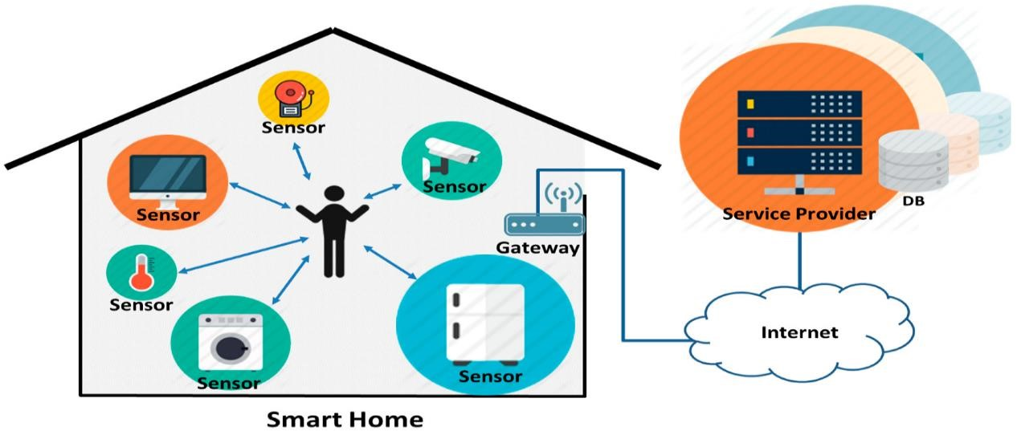

*Figure 1:Smart home controlling Method*

## 1.7 Objectives of the Project

* To create and Develop a Cost-Effective Solution making smart home controller device with accessible to a wider range of homeowners.
* To make a daily routine at home easier.
* To Enhance Home Automation and Implement advanced home automation features that enable users to remotely control and automate various devices and appliances.
* To Create a User-Friendly Interface and mobile application that allows homeowners to interact with and manage their smart home devices effortlessly.
* To Integrate Energy Efficiency, incorporate energy-saving features and automation capabilities to optimize energy consumption, reduce utility costs, and promote sustainable living.
* Enhance home security by incorporating smart security features like remote access control, motion detection, and live monitoring to bolster overall safety.
* To Enable Remote Monitoring Enable homeowners to remotely monitor their smart home devices and receive alerts or notifications on their mobile devices, providing peace of mind when away from home.
* To Support Interoperability, ensure compatibility with various smart home devices and protocols, allowing the smart home controller.
* To develop Smart home controller kit including smart door, smart lighting system, smart water applying system, smart security system, automated irrigation system, Backup solay system, gas leak detecting system.
* To saving time and manpower.
* To creating a human tendency toward smart technology in Sri Lanka.

## 1.8 Thesis Layout

**Chapter 1 – Introduction**

we delve into the history of the study, identify the problem at hand, and explore the research gap that exists in the current domain. We elucidate the methodologies employed to address this challenge adeptly, delineating the ambitions and purposes, spanning across broad as well as specific objectives, that we strive to realize through this investigation. This section furnishes a holistic synopsis of the complete research undertaking, establishing the groundwork for the ensuing chapters within this study.

#### Chapter 2 – Literature Review

The second chapter provides a thorough assessment of previous research on pick-andplace mechanisms, techniques, and advancements. It highlights how the research problem is conceptualized and the relationship of variables to earlier work. It sets the foundation for our study and guides our investigation to address research gaps.

#### Chapter 3 – Materials and Methods

This chapter will detail the materials and methods used for measurements in the current study's workshop experiments and overall thesis work. It will discuss the importance of the information related to the design process, material selection, materials used, and the method employed for designing and developing this pick-and-place mechanism.

#### Chapter 4 – Results and Discussion

Chapter four focuses on meeting the study's analysis technique-related objectives. It presents all the assessment sections of the workshop scale experiments' results that were produced to achieve the required goals.

#### Chapter 5– Conclusions and Recommendations

This chapter offers an overview of the research and draws inferences from the data analysis findings. Additionally, this chapter provides a broad overview for upcoming research.

## 1.9 Chapter Summery

The introduction of this chapter offers a high-level explanation of the study's purpose and identifies the specific problem it aims to address. The contextual information provided helps in identifying the research gap. Moreover, the chapter emphasizes the overall purpose and goals of the study.

# CHAPTER 2

**LITERATURE REVIEW**

## 2.1 Chapter Introduction

This chapter aims to identify the basic concepts of the study. The chapter has gone through with previous literature related to the topic.

## 2.2 Overview Smart Home Control

The concept of a "Smart home controller" has captured the imagination of many, and recent advancements in electronic technologies have brought us closer to realizing this futuristic vision. enabling devices to gather data from the environment and take appropriate actions. The long-term goal of smart technology is to enhance human wellbeing, making it the foundation for ground-breaking ideas like the "smart home controller." (Paul et al., 2018).

In the context of smart homes, various innovative systems have been proposed, allowing for control through a range of methods, such as Bluetooth, the web, SMS, and more. With the majority of modern devices supporting Bluetooth connectivity, the cost of implementing smart home systems has become more feasible. However, while the ability to control the environment is present, some systems may lack comprehensive functionality, limiting their potential as a fully integrated and affordable solution. (Jabbar, W. A. et al., 2019).

As the market for smart home controller expands globally, the advantages provided by smart technology have sparked excitement among practitioners and academics alike. The increasing device interoperability and the availability of smarter products and services have fuelled this growth. The field of smart home technology has undergone extensive study and practical application, with a focus on improving human lives and transforming the way we interact with our living spaces. With ongoing advancements, the dream of a fully functional and affordable smart home may soon become a reality for more people, bringing convenience, efficiency, and enhanced living experiences to homeowners worldwide. (Hui, T. K. et al., 2017).

## 2.3 Evolution of the Intelligent Home Control Hub

The history of home automation can be traced back to the 19th century when the concept of automating household tasks and operations first emerged. However, it was in April 1968 that a significant development took place with the creation of the Electronic Computing Home Operator. This early automation system was built using spare electronics and laid the groundwork for future advancements in the field.

In the following years, the X10 standard was introduced, which allowed for the transmission and reception of messages such as "turn ON" and "turn OFF" through radio frequency. While this was a pioneering technology, it had its limitations and disadvantages. Fast forward to the modern era, the invention of the Raspberry Pi, a small credit card-sized computer with a plethora of peripherals and communication ports like Ethernet, USB, and HDMI, revolutionized the home automation landscape. This opened up new possibilities and made home automation more accessible and fascinating. (Vikram et al., 2017)

Today, home automation, also known as "smart homes" or "intelligent homes," encompasses a wide range of technologies and capabilities. It includes not only traditional building automation features like door and window controls and climate controls but also advanced functionalities such as controlling multimedia home theatres, smart security systems, plant watering, and much more. The control of smart homes relies on various technologies, including GSM, WIFI, Bluetooth and others. These technologies enable seamless communication between different devices and systems, empowering homeowners to monitor and control their homes remotely. (Wenbo et al., 2015)

With the continued advancements in technology and the increasing availability of smart devices, home automation has become more user-friendly and practical than ever before. Smart homes offer numerous benefits, including improved energy efficiency, enhanced security, and the convenience of remotely managing various household tasks. the journey of home automation has evolved over time, from early experiments with basic electronics to the modern era of interconnected smart homes (Purtill, J.

2022, January 15).

## 2.4 Wireless Communication

In this project, a basic smart home prototype system controlling will be developed, enabling wireless monitoring and control through a node red databash. The communication methods used for this system are WIFI and the Internet. The system's crucial components include motion, temperature, and lighting features, all of which can be remotely managed through the node red.

Over the last decade, academic scholars have proposed various IoT-related home automation systems in the literature. These systems have employed different wireless technologies, each with its own set of advantages and disadvantages. For instance, WIFI-based automation is cost-effective, quick to deploy, and straightforward, but it has limited range and can only be used over short distances. Other widely used wireless technologies include NODEMCU board and Internet. Internet offers long-distance connectivity at the cost of a mobile service provider's plan, making it suitable for remote monitoring. It is energy-efficient and cost-effective, although it requires maintenance and has lower data speed and network stability. Considering these various options, the chosen communication methods for the smart home prototype ensure efficient and reliable functionality while keeping affordability in mind. ( Nord, J. H., Koohang, A., & Paliszkiewicz, J. 2019)

## 2.5 A Smart Door System

Smart door locks offer the convenience of granting access to a person who has been authenticated, making it possible to open and close the door without the need for a physical key. The advantages of using smart door locks are numerous. Firstly, it enhances security by ensuring that only verified individuals can operate the door, reducing the risk of unauthorized access. Secondly, the accessibility through a smartphone eliminates the possibility of losing or misplacing traditional keys, providing a more convenient and reliable way of entry.

Another method is based on Bluetooth technology, where regular commands are sent to lock or unlock the door. This approach offers a more secure and reliable means of door control, ensuring that only authenticated users with the appropriate Bluetooth connection can operate the lock.

An alternative approach is centred around RFID (Radio Frequency Identification), but it should be noted that RFID tags can be rendered ineffective when exposed to a strong magnetic field, which could be a limitation in certain scenarios.

Lastly, some smart door lock systems incorporate a motion sensor, such as a PIR (Passive Infrared Sensor), to automatically lock or open the door based on detected movement. This method adds an additional layer of convenience and automation, ensuring that the door remains securely locked when not in use and automatically unlocks when an authorized person approaches (Hassan, S. A., & Eassa, A. M. 2022).

Each of these methods has its advantages and limitations, and the choice of which approach to use will depend on the specific requirements and security considerations of the smart home system. Ultimately, smart door locks provide enhanced security, ease of access, and seamless integration with other smart home technologies, making them an appealing and valuable component of modern smart homes. (Parab, P. et al.,2018)

## 2.6. Automated irrigation system

An automated irrigation system based on a variable rate microcontroller is also introduced, running solely on solar power. This system enables farmers to remotely access information about moisture levels in agricultural properties and manage the water pump accordingly through their mobile phones. The automated irrigation system continuously monitors water levels in agricultural areas, even in the absence of farmers. In contrast, manual water tank systems require the user to be present at the water pump to control its operation. However, an automated system using an Android application allows for remote ON and OFF control of the water pump. Researchers have explored various hardware and technology options to develop water automation systems, including water pump controllers, water level sensing, water billing with leak detection, and control. (Sangeetha., at al 2022)

The Automated Water Management System (AWMS) exemplifies the automation of water management through a mobile application, simplifying daily life. It utilizes sensors and data to manage water distribution and respond to water tank conditions based on water surface levels. WMS can service a water tank, automatically turning the motor ON or OFF based on water levels. Users can also adjust water temperature, and their water line is automatically cut off when they have consumed their allocated water allowance. Through mobile texting, users can monitor their water consumption and receive notifications before their water line is cut off. Overall, these systems offer efficient water management solutions and contribute to sustainable water usage practices. (Ahemed & Amjad, 2019)

# 2.7. Smart Gas Leak Detecting System with Auto exhaust.

The use of Liquid Petroleum Gas (LPG) is common in homes for various purposes such as cooking, heating, and recreational activities like camping and barbecues. LPG primarily consists of propane and butane, which are highly combustible molecules. However, the risk of gas leaks poses a potential danger, leading to fires or explosions in buildings or vehicles. To address this safety concern, gas companies add odorants to LPG to make leaks detectable. Nevertheless, some individuals with impaired sense of smell may not benefit from this safety measure, necessitating the use of a gas leakage detector.

This paper introduces an affordable and effective audio-visual solution for detecting LPG leaks in both residential and commercial settings. The system provides audible and visual alerts to notify users of potential hazardous situations. In low-risk scenarios, such as unattended appliances or gas flames being blown out, warning signals in the form of beeps are provided. The wireless gas leak detection system designed for homes allows for easy mobility inside the premises, enhancing safety measures for occupants. By offering a reasonably priced audio-visual method, this system aims to shield individuals from the risks associated with gas leaks, ensuring a safer living and working environment. (Sharma, M. et al., 2018).

# 2.8. Smart Lighting, fan and power outlet controlling System.

The home lighting system plays a crucial role in enhancing human life, and modern computer technology has revolutionized the way we control and manage home appliances. A computer-controlled home lighting system offers automation and convenience, just like having a virtual maid at our service. This paper presents a flexible design strategy for a computer-controlled home lighting system, where various user interfaces, such as processing software, enable visualized impact and control over connected appliances. This system proves especially beneficial for individuals with physical impairments, as it allows them to manage lighting and other appliances effortlessly, saving both time and effort (Fuada, S. et al., 2021).

Efficient utilization of electricity is becoming increasingly essential, and to achieve this, new technologies and control systems are necessary. IoT-based control systems and the Internet of Things (IoT) are effective solutions for improving home energy efficiency. IoT is already making its way into the building industry, particularly with contemporary Building Automation Systems (BAS). While newer homes readily integrate IoT devices, older homes may lack the infrastructure for seamless IoT integration. Nevertheless, with modest investments, these older homes can be transformed into smart homes, as most of them are already connected to the internet through Wi-Fi or cellular systems like LTE 4G and 5G. (Minoli, D., Sohraby, K., & Occhiogrosso, B. 2017)

A smart home utilizes internet-connected gadgets to enable remote access, monitoring, management, and control of various home systems and appliances, such as televisions, air conditioners, and lighting systems. By implementing an IoT platform, including suitable gateways and sensor devices, homeowners can access a wide range of services and turn older houses into highly intelligent, connected living spaces (Sailaja, K., & Rohitha, M. 2018) Previous research on lighting control has focused on various approaches, including integrating occupancy sensors to automatically turn on lights when needed and implementing sensor networks or manual user input to adjust illumination levels. Intelligent lighting control and daylight harvesting have also been studied to optimize energy efficiency. However, some implementations using sensor networks can be costly.

Overall, computer-controlled home lighting systems and IoT-based control systems hold great promise in enhancing energy efficiency, convenience, and accessibility in modern homes. The integration of these technologies opens up new possibilities for creating smart and connected living spaces for all homeowners.

# 2.9. Hazard detection, protection and Smart Security System

Home security has witnessed significant advancements in the past century, and it continues to evolve, driven by technological innovations. Smart homes are at the forefront of this evolution, integrating security as a key component among their features. These modern Smart home controllers offer residents a comfortable, practical, and secure environment, going beyond the capabilities of traditional security systems.In a study conducted by (Sattaru, P. K. et al., 2023)

Two home security system proposals were put forward. The first system utilizes a web camera that triggers a security alert and sends an email to the owner whenever movement is detected in front of the camera. The second approach involves the use of the microcontroller, the GSM Module, sensors, relays, and buzzers to transmit SMS alerts.

The Internet of Things (IoT) has played a significant role in driving the popularity of smart home technology. The security feature of these systems enables quick and convenient locking and unlocking of gates or entrances. presented a Raspberry Pibased face recognition security system that can be integrated into a smart home setup. The system utilizes Principal Component Analysis (PCA) as the classifier and Eigen face for feature extraction. The facial recognition algorithm is linked to a relay circuit that controls the door's magnetic lock, providing enhanced security. The suggested solution achieved an impressive facial recognition accuracy of approximately 90%.

## 2.10. Energy Meter with data collecting and monitoring system

Creating an IoT-based Electricity Energy Meter using an ESP32 to monitor data on Node-RED involves selecting appropriate current and voltage sensors to measure power consumption and total power consumed. The SCT-013 Non-Invasive AC Current Sensor Split Core Type Clamp Meter Sensor, capable of measuring AC current up to 100 amperes, and the ZMPT101B AC Voltage Sensor Module, which offers precise AC voltage measurement with a voltage transformer, are considered the best options in the market.

To build this system, we'll interface the SCT-013 Current Sensor and ZMPT101B Voltage Sensor with an ESP32 WIFI module. Data collected from these sensors will be transmitted to a Node red. The Node red Application Dashboard will then present key metrics such as Voltage, Current, Power, and total energy consumption in kilowatt-hours (kWh). this setup leverages the SCT-013 Current Sensor and ZMPT101B Voltage Sensor in conjunction with an ESP32 to monitor and report electricity consumption data accurately via Node-RED. The Node red dashboard serves as the user interface, displaying vital information about the electrical parameters being measured. (Kamal, N., & Ali, M. S. 2023)

#### Chapter Summary

The concept of smart homes has evolved significantly over the years, with security becoming a crucial component of these modern living spaces. Traditional security systems have given way to more advanced solutions, harnessing the power of technology to offer enhanced protection and convenience. Smart homes provide residents with a comfortable, practical, and secure environment. In recent studies, researchers have proposed various smart home security systems. One approach involves using web cameras to detect movement and trigger security alerts, ensuring owners are promptly notified via email. Another system utilizes microcontroller, sensors, relays, and buzzers to transmit SMS alerts in case of security breaches.

The Internet of Things (IoT) has played a pivotal role in the growing popularity of smart home technology. Among the essential features of such systems is face recognition security. A Raspberry Pi-based face recognition system was introduced, achieving an impressive accuracy rate of around 90%. This system seamlessly integrates with smart homes, allowing for convenient and secure access control. With continuous advancements in technology and the increasing adoption of IoT, smart home security is poised to become even more sophisticated. These systems not only offer increased safety but also empower homeowners with better control and monitoring of their living spaces. As the smart home revolution continues, security remains a top priority, ensuring that residents can enjoy a comfortable and secure living experience.

# CHAPTER 3

**MATERIALS AND METHODS**

## 3.1 Chapter Introduction

The details of the study aimed at achieving the objectives are comprehensively presented in the Materials and Techniques chapter. This chapter covers various aspects, including the materials used, the methodology employed, morphological analysis, SolidWorks design, programming structure, and the wiring diagram. Moreover, it elaborates on how the variables were operationalized and the data analysis methods applied in this research.

## 3.2 Materials

There are two basic materials were used to develop the intelligent home control hub for mordent living homes. These are, hardware component and software components.

### 3.2.1 Hardware Component

###### 3.2.1.1 ESP8266 NODEMCU Board

This module has complete control over all other components, and it simplifies data transfer without the need for additional modules due to its dual Wi-Fi and Bluetooth accessibility. Esp8266 Wi-Fi module is an open-source development board and firmware based in the widely used ESP8266 -12E Wi-Fi module. It allows you to program the ESP8266 Wi-Fi module with the simple and powerful LUA and C++ programming language. Additionally, it prioritizes reduced power usage compared to other controllers.

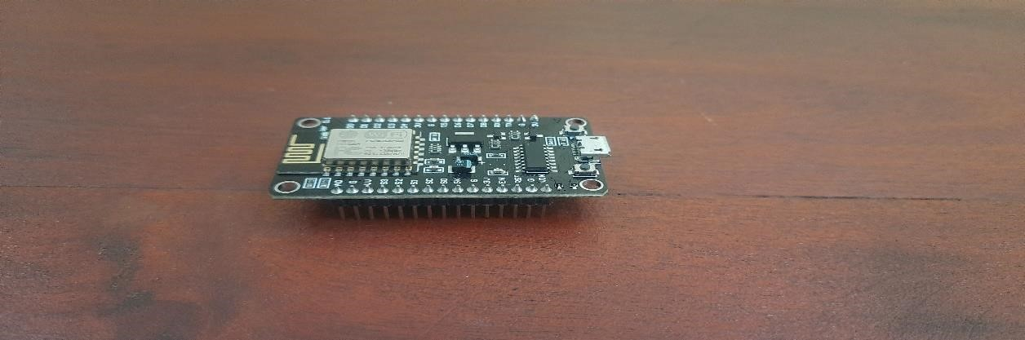

#### *Figure 2: ESP8266 NODEMCU Board*

##### 3.2.1.2 Ultra-Sonic Sensor

Ultrasonic sensors are acoustic sensors categorized into three main types: transmitters, receivers, and transceivers. Transmitters convert electrical signals into ultrasound, receivers convert ultrasound into electrical signals, and transceivers can both transmit and receive ultrasound. This module comprises ultrasonic transmitters, receivers, and control circuits. It is highly regarded in the electronic market for its stable performance and high ranging accuracy. The module has 5 pins: VCC, Trig, Echo, GND, and OUT. It performs optimally within a 30-degree angle and is compatible with an electronic brick interface. Additionally, it features dual transducers for enhanced functionality.



#### *Figure 3 : Ultra-Sonic Sensor*

##### 3.2.1.3 MQ-2 sensor

The MQ-2 sensor is a popular gas sensor widely utilized for detecting various flammable and combustible gases, such as methane, butane, propane, and alcohol vapours. It finds applications in gas leak detection systems, industrial environments, and DIY projects. Below are the fundamental materials and methods used for operating the MQ-2 gas sensor:



*Figure 4:MQ-2 sensor*

##### 3.2.1.4 PIR (Passive Infrared) Motion Sensor

The PIR (Passive Infrared) motion sensor is widely used for detecting motion in its vicinity, and it finds applications in security systems, automatic lighting, and various other fields. To use the PIR motion sensor as a motion detector in a home prototype, a Panasonic PIR motion sensor was employed as an input device. The motion sensor was installed inside the residence, and its wires were connected directly to the Arduino Uno to monitor any movement. The sensor's output was linked to the Arduino Uno's analogue pin A2. The sensor's output is a digital signal that can be either high or low.



#### *Figure 5 : PIR (Passive Infrared) motion sensor*

##### 3.2.1.5 Soil Moisture Sensor

Soil moisture sensors measure the amount of water present in the soil indirectly, using properties such as electrical resistance, dielectric constant, or neutron interaction as proxies. This measurement is crucial for understanding soil water content, which affects plant growth and agricultural practices. Calibration is essential due to variations in environmental factors like soil type, temperature, and electric conductivity. These sensors are used in hydrology, agriculture, and gardening, providing valuable data for farmers and gardeners. Some sensors, like tensiometers and gypsum blocks, measure soil water potential, complementing the information obtained from volumetric water content sensors.

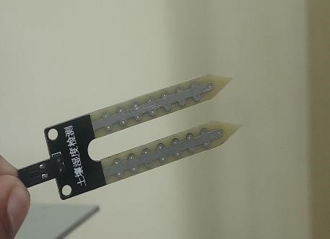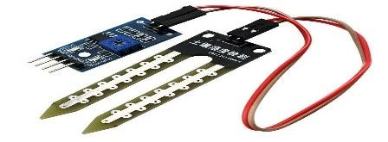

#### *Figure 6: Soil Moisture Sensor*

##### 3.2.1.6 Relay Module

A power relay module is an electromechanical switch operated by an electromagnet. It controls high-power devices with low-power signals from a microcontroller. The relay consists of a coil, an iron yoke, a movable armature, and sets of contacts. When energized, the armature moves, making or breaking connections between contacts. GEP Power Products is a leading manufacturer of high-power relay modules rated up to 70 amps, offering seamless integration in high-power distribution applications. Their products come with integral mounting brackets and various options for wire retention, providing efficient power distribution solutions for the off-road industry.



#### *Figure 7: Relay module*

##### 3.2.1.7 Piezoelectric Buzzer

The buzzer module consists of an active piezoelectric buzzer, controlled by the NODEMCU, which activates the buzzer when receiving signals. When a strong signal is received, the module produces sound. It operates by passing a fluctuating signal through a coil, generating a fluctuating magnetic field that causes the disk to vibrate at the same frequency. This magnetic buzzer serves as an alarming tool in the circuit design, triggering an alarm sound in case of gas leakage to alert the homeowner.



#### *Figure 8: Two pin Buzzer*

##### 3.2.1.8 5w LED Bulb

An LED light bulb is a type of solid-state lighting (SSL) product that utilizes LightEmitting Diodes (LEDs) to produce light, rather than traditional screw-in connections. LED lighting serves as an eco-friendly alternative to incandescent bulbs. The LED light bulb incorporates a semiconductor component that emits visible light when an electric current passes through it.

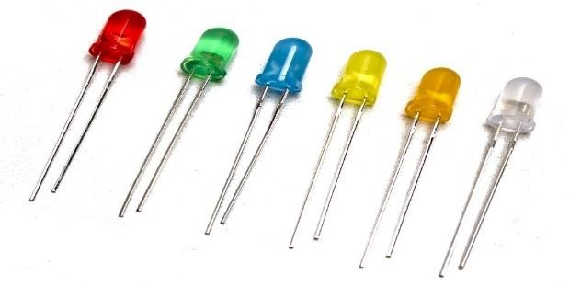

*Figure 9: Set of Light Emitting Diodes*

##### 3.2.1.9 Toggle Switch

Toggle switches are electrical switches that feature an operating lever that can be moved in different directions, such as up and down or left and right, to control an electrical circuit. These switches come in various configurations, including single-pole single-throw (SPST), single-pole double-throw (SPDT), double-pole single-throw (DPST), and double-pole double-throw (DPDT). They are widely used in various applications, from household appliances to industrial machinery, due to their simplicity and reliability. The basic mechanism of a toggle switch involves a springloaded lever that can maintain its position in either the ON or OFF state. When the lever is pushed in one direction, it makes or breaks the electrical connection, allowing or interrupting the flow of current through the circuit.

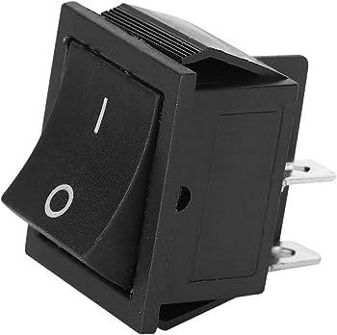

#### *Figure 10 : Toggle Switch*

##### 3.2.1.10 Solenoid Valve

A 12V solenoid valve is an electrical device commonly used in fluid control systems. It consists of a coil and a valve mechanism. When a 12-volt electrical current is applied to the coil, it generates a magnetic field, which in turn activates the valve mechanism. This mechanism allows the valve to open or close, regulating the flow of liquids or gases through the system. 12V solenoid valves are widely used in applications such as irrigation systems, automotive control systems, industrial machinery, and home automation setups. Their ability to be controlled remotely using low-voltage electrical signals makes them versatile components for managing the flow of fluids in various scenarios.

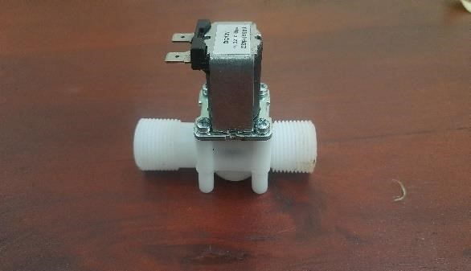

*Figure 12: Brass Solenoid valve Figure 11: 12V Solenoid valve - 1/2"*

##### 3.2.1.11 Wi-Fi Router

A WIFI router is a device that wirelessly connects multiple devices to a local network and the internet, using radio frequency signals. It acts as a central hub for data communication, allowing devices like laptops, smartphones, and smart TVs to access and share online resources without the need for physical connections.

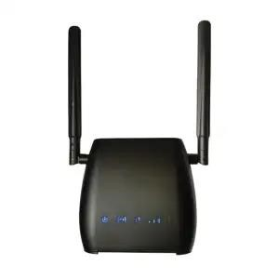

#### *Figure 13: Dialog 4G Router*

##### 3.2.1.12 Gear Motor

A gear motor is an integrated unit that combines a motor and gearbox. By adding a gear head to the motor, the speed is reduced while the torque output is increased. The performance of a gear motor is primarily measured by its speed (rpm), torque, and efficiency (percent). To select the most suitable gear motor for your application, it is essential to determine the specific load, speed, and torque requirements.

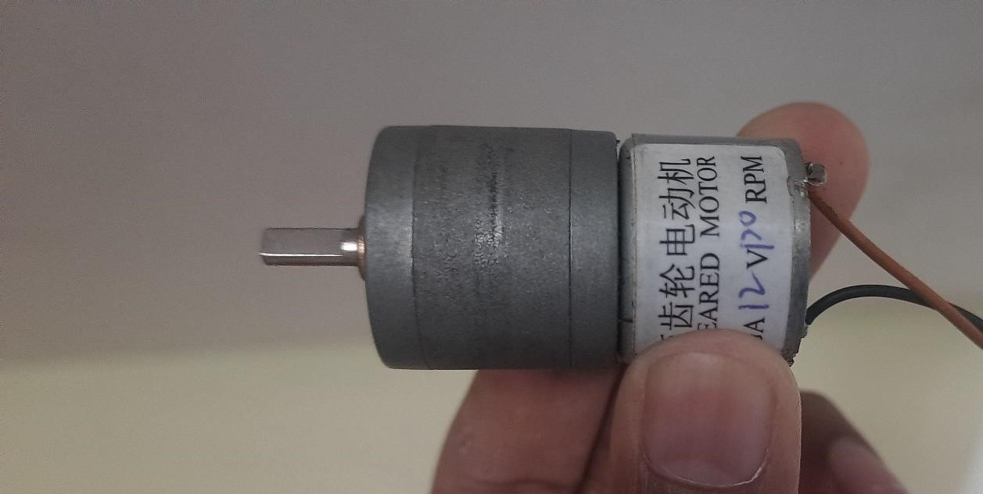

#### *Figure 14: 12V Gear Motor*

##### 3.2.1.13 Jumper Wires

A jump wire (also known as jumper wire, or jumper) is an electrical wire, or group of them in a cable, with a connector or pin at each end (or sometimes without them – simply "tinned"), which is normally used to interconnect the components of a breadboard or other prototype or test circuit.

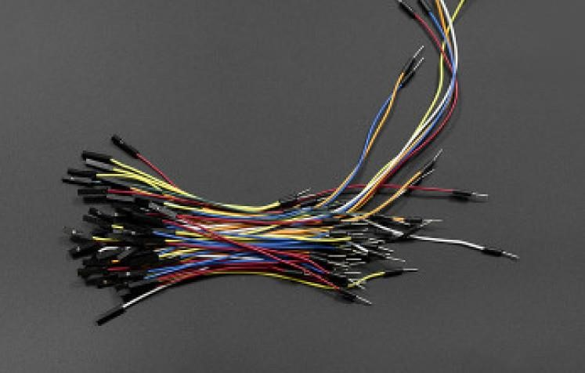

#### *Figure 15: Jumper Cables*

##### 3.2.1.14 Door Lock 12V DC

The safety of your house is very important that why we lock doors. Sometimes we miss our home key in house when we can use this interface to open the door through our mobile or computer and now a days every person has its own android mobile.

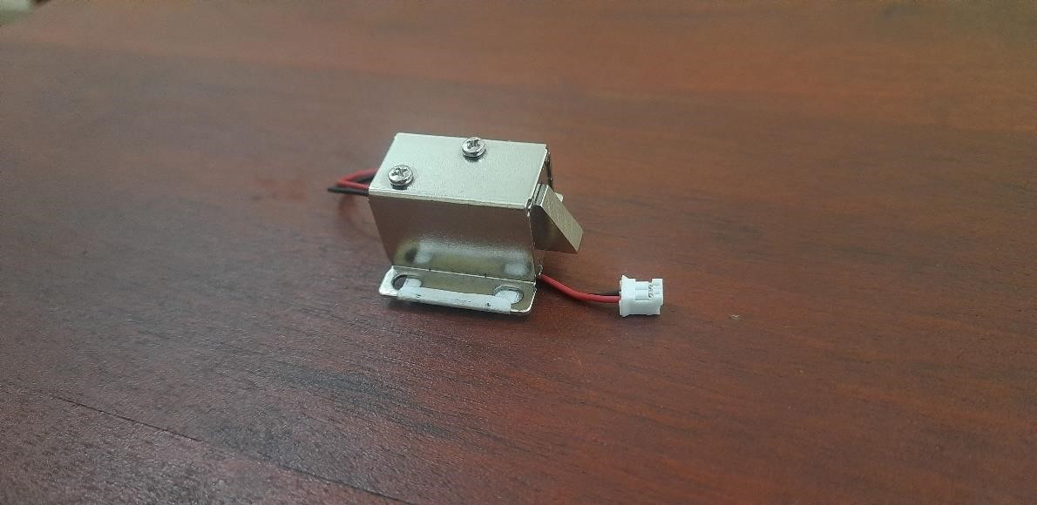

#### *Figure 16:12V Electric door lock*

##### 3.2.1.15 Light-Dependent Resistor (LDR)

LDR is a type of resistor where the resistance decreases with increasing light intensity. It is used in various applications, such as light-sensitive circuits, streetlights, and camera exposure control.

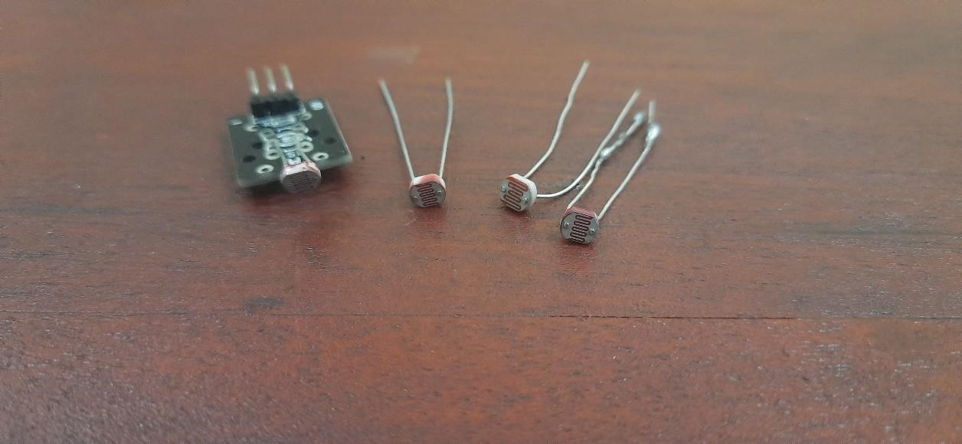

*Figure 17: 3.2.1.15 Light-Dependent Resistor (LDR)*

**3.2.1.16 12V electronic lock** an electronic locking system that operates on a 12-volt power supply. Here are some general aspects to consider regarding electronic locks powered by 12 volts. These locks require a power source of 12 volts DC (Direct Current). The power supply may come from batteries, a dedicated power adapter, or another source capable of providing the required voltage. Electronic locks often come with advanced security features, such as programmable codes, audit trails, and the ability to integrate with other security systems.

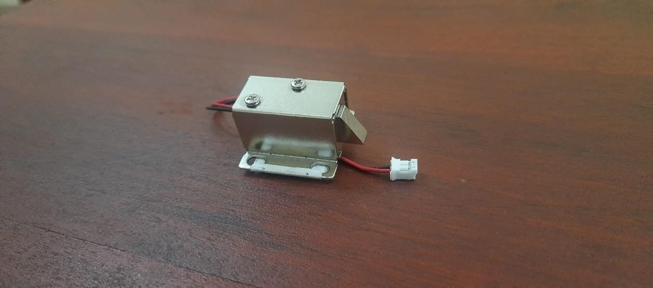

*Figure 18 : 12V electronic lock*

##### 3.2.1.17 IC - TDA2822

The TDA2822 is a dual low-voltage power amplifier IC (Integrated Circuit) ic designed to operate on a low voltage, typically around 1.8 to 15 volts. This makes it suitable for battery-operated devices. The IC is available in various packages, including dual in-line packages (DIP) and surface-mount packages.



*Figure 19 : IC - TDA2822*

##### 3.2.1.18 Resistors 100om, 1k, 10k

Resistors are passive two-terminal electronic components that limit the flow of electric current. They are fundamental components in electronic circuits and are used for various purposes, including setting bias points, dividing voltages, limiting current, and providing specific values of resistance in a circuit. to choose the right type, resistance value, power rating, and tolerance according to the requirements of your circuit. The colour code, if applicable, is a crucial aspect for identifying the resistance value of fixed resistors.



*Figure 20 : Resistors 100om, 1k, 10k*

##### 3.2.1.19 12V water pump

A 12V water pump refers to a water pump designed to operate on a 12-volt direct current (DC) power supply. These pumps are commonly used in various applications, especially in scenarios where a standard household power supply is not available, such as in recreational vehicles, boats, off-grid systems, and portable setups. Here are some key points related to 12V water pumps. When selecting a 12V water pump, it's important to consider the specific requirements of your application, including the flow rate needed, the vertical lift (head), and any other features required for the task at hand. Always need to follow the manufacturer's guidelines for installation, operation, and maintenance.



*Figure 21: 12V water pump*

##### 3.2.1.20 I2C LED display

I2C display typically refers to a display module that uses the I2C (Inter-Integrated Circuit) communication protocol for interfacing with a microcontroller or other devices. The I2C protocol is a popular choice for connecting peripherals, such as displays, sensors, and other devices, because it allows multiple devices to be connected to the same bus using only a few wires. I2C is a serial communication protocol that uses two wires: SDA (data line) and SCL (clock line). It enables communication between a master device (like a microcontroller) and one or more slave devices.

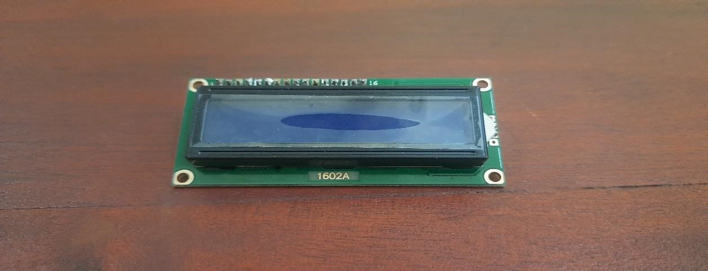

*Figure 22 : I2C LED display*

##### 3.2.1.21 Sunk box and cover

Providing a secure and protected enclosure for electrical connections and wiring and provide space to fix switches.

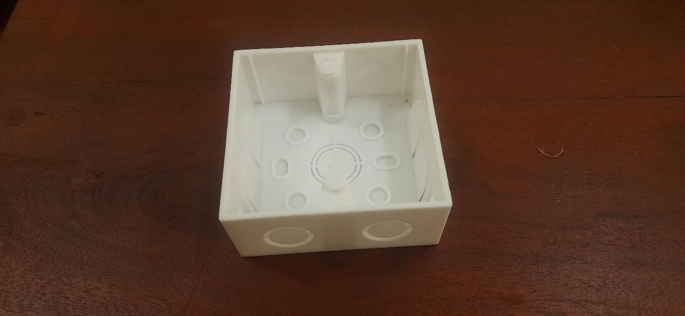

*Figure 23 : Sunk box and cover*

##### 3.2.1.22 Solar panel

Solar technologies convert sunlight into electrical energy either through photovoltaic (PV) panels or through mirrors that concentrate solar radiation. This energy can be used to generate electricity or be stored in batteries.

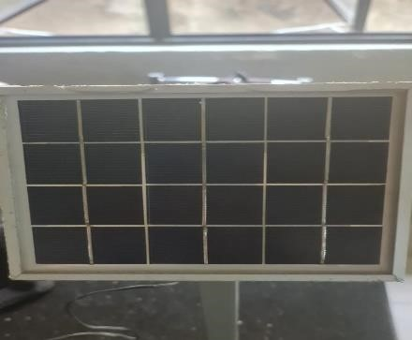

*Figure 24: Solar panel*

##### 3.2.1.23 SCT-013 Current Sensor

The [SCT-013](https://www.mcielectronics.cl/website_MCI/static/documents/Datasheet_SCT013.pdf) is a Non-invasive AC Current Sensor Split Core Type Clamp Meter Sensor that can be used to measure **AC current** up to 100 amperes. Current

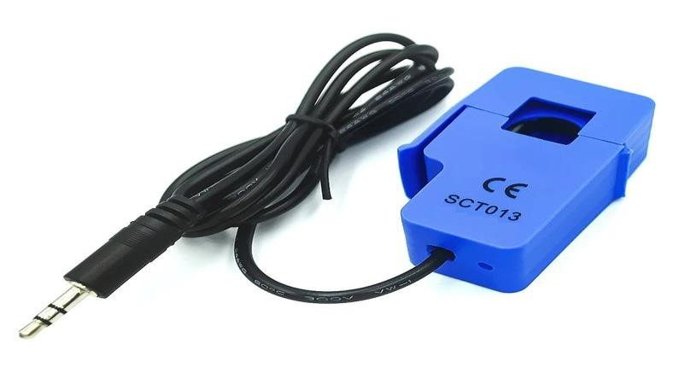

*Figure 25 : SCT-013 Current Sensor*

transformers (CTs) are sensors are for measuring alternating current. They are particularly useful for measuring whole building electricity consumption. The SCT013 current sensors can be clipped straight either to the **live** or **neutral wire** without having to do any high voltage electrical work. Like any other transformer, a **current transformer** has a primary winding, a magnetic core, and a secondary winding. The secondary winding comprises many turns of fine wire housed within the casing of the transformer.

##### 3.2.1.24 ZMPT101B AC Single Phase Voltage Sensor

The [ZMPT101B](https://innovatorsguru.com/wp-content/uploads/2019/02/ZMPT101B.pdf) AC Single Phase voltage sensor module is based on a high precision ZMPT101B voltage Transformer used to measure the accurate AC voltage with a voltage transformer. This is an ideal choice to measure the AC voltage using Arduino or ESP8266. The Modules can measure voltage within 250V AC voltage & the corresponding analog output can be adjusted. The module is simple to use and comes with a multi-turn trim potentiometer for adjusting and calibrating the ADC output.

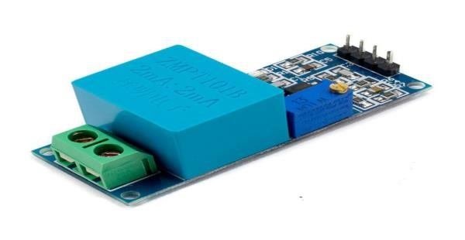

*Figure 26: ZMPT101B AC Single Phase Voltage Sensor*

### 3.2.2 Software Component

###### 3.2.2.1 Arduino IDE

The smart home system will be operated using an Arduino-based microcontroller, which takes advantage of the open-source electronics platform. Arduino greatly simplifies the process of developing both hardware and software required for the system to function effectively. The microcontroller, based on the node mcu Board, can be conveniently powered, programmed, and communicated with via USB. It comes equipped with a power and reset circuitry setup through Universal Serial Bus. To program the microcontroller, developers can utilize the dedicated Arduino IDE (Integrated Development Environment), which offers a user-friendly interface for coding and development



*Figure 27: Arduino LOGO*

**3.2.2.2 Node RED Database interface.**

Node red database is a powerful software suite for prototyping, deploying, and managing connected electronic devices at any scale. It enables users to connect hardware to the cloud, create mobile and web database, analyse data, and remotely control devices from anywhere. Ideal for personal projects or large-scale commercial deployments.

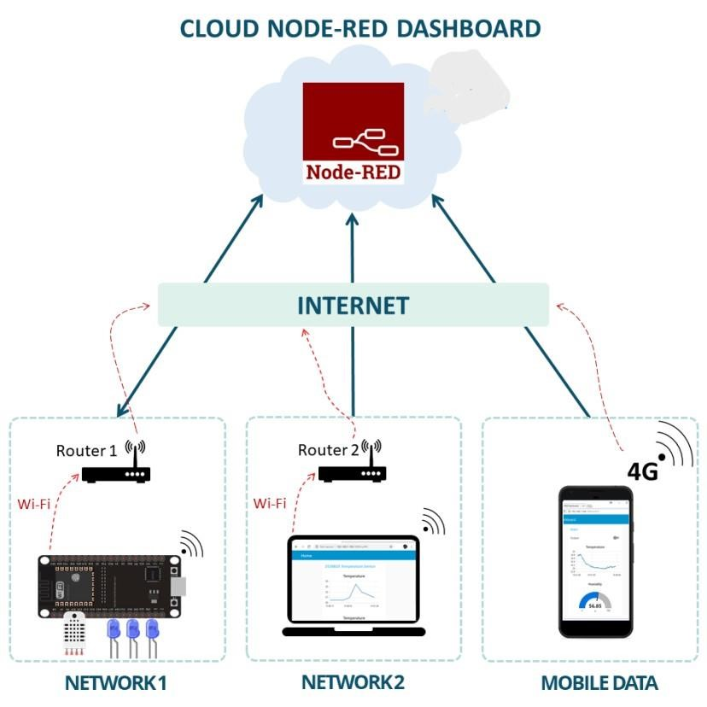

*Figure 28: node red Data Sever Diagram*

#### MQTT web server – Message Queuing Telemetry Transport

A messaging protocol called MQTT (Message Queuing Telemetry Transport) is designed for Internet of Things (IoT) devices with exceptionally high latency and little bandwidth. The Message Queuing Telemetry Transport protocol is the best one for machine-to-machine (M2M) communication since it is tailored for low-bandwidth, high-latency settings. MQTT is run by a central broker and operates on the publisher/subscriber paradigm. This indicates a lack of direct communication between the sender and the recipient. All receivers who have expressed interest in certain messages (those who have been "marked by the topic") receive the data because they have signed up as subscribers after the data providers post their data.

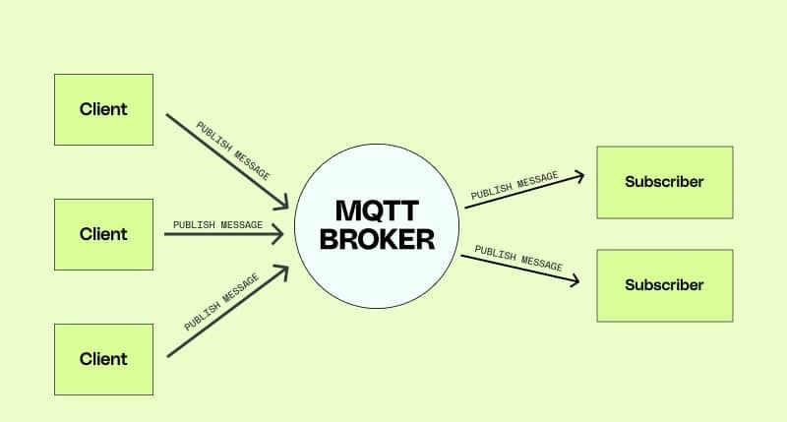

*Figure 29 : MQTT server working principle*

**What is the principle behind MQTT?**

Clients and servers have direct connection with one another. The clients ask the server for resources or data. The publish/subscribe mechanism is the foundation of the MQTT protocol. In a conventional network, the server processes the request and responds. However, MQTT separates the message sender (publisher) from the message recipient (subscriber) using a publish/subscribe paradigm. Instead, the communication between publishers and subscribers is handled by a third component known as a message broker. All incoming communications from publishers must be filtered by the broker in order to properly distribute them to subscribers.

**What are MQTT components?**

MQTT implements the publish/subscribe model by defining clients and brokers as below.

#### MQTT client

Any machine that uses a MQTT library, from a server to a microcontroller, is referred to as a MQTT client. The client takes on the roles of a publisher and a receiver depending on whether it is sending or receiving messages. Basically, a MQTT client device is any device that uses MQTT to interact across a network.

#### MQTT broker

The backend system that synchronizes messages across the many clients is the MQTT broker. The broker's duties include receiving and filtering communications, finding customers who have subscribed to each message, and forwarding the messages to them. It is also in charge of additional duties like

* Authorizing and authenticating MQTT clients
* Passing messages to other systems for further analysis
* Handling missed messages and client sessions

#### MQTT connection

An MQTT connection is used to start communication between clients and brokers. Clients start a connection by sending the MQTT broker a CONNECT message. By sending back a CONNACK message in response, the broker verifies that a connection has been made. The broker and the MQTT client both need a TCP/IP stack to interact.

The only connection clients ever make is with the broker.

#### MQTT working principle

1. A MQTT client establishes a connection with the MQTT broker.
2. Once connected, the client can either publish messages, subscribe to specific messages, or do both.
3. When the MQTT broker receives a message, it forwards it to subscribers who are interested.

#### MQTT topic

The MQTT broker filters messages for MQTT clients using keywords, which are referred to as "topics." Similar to a file or folder directory, topics are arranged in a hierarchy. Consider a smart home system that controls various smart gadgets on each level of a multilevel home, for instance. The MQTT broker may then categorize topics as follows:

#### MQTT publish

MQTT clients publish messages with byte-formatted topic and data. The data format, such as text data, binary data, XML, or JSON files, is decided by the client. For instance, a bulb in the smart home system may post a message under the heading "light in the living room."

**MQTT subscribe**

To receive messages on subjects of interest, MQTT clients send a SUBSCRIBE message to the MQTT broker. A list of subscriptions and a distinctive identifier are both included in this mail. The smart home app on your phone, for instance, would want to show how many lights are on in your home. It will subscribe to the light subject and raise the overall message counter.

## 3.3 Methods

The project implements Wi-Fi data transfer capabilities using NODEMCU boards, which are connected to a real-time database. This enables control and monitoring of all systems through a mobile application. The real-time database is built on the Node red database server, and the mobile application is developed using the Node red data base. The development process involved a systematic approach with each decision and action being well-documented. A comprehensive flowchart was created to illustrate the entire project workflow, outlining the various steps and methodologies employed to achieve the desired results. Throughout the project, careful steps were taken to ensure successful outcomes and seamless functionality between the NODEMCU boards, the real-time database, and the mobile application. The utilization of Node red data base server and Node red database facilitated efficient communication and data exchange. By maintaining thorough documentation, the development team ensured transparency, traceability, and the ability to troubleshoot any potential issues. The project's systematic approach and well-documented workflow contribute to its successful implementation and functionality.

**Work Flow Chart**

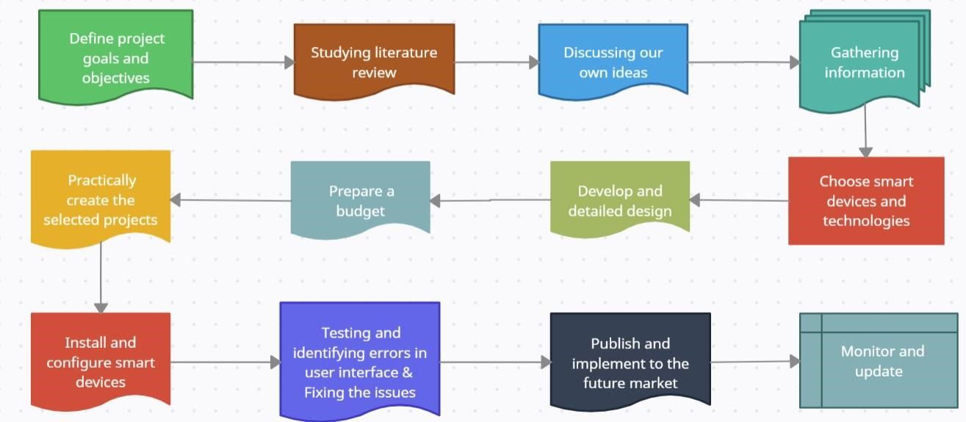

### 3.3.1 Auto Irrigation System.

The Node red database provides users with the ability to monitor and control the soil moisture and water level sensors connected to the ESP8266 board. Through the application, users can view the real-time values of these sensors, allowing them to keep track of the plant's environmental conditions. Moreover, the Node red database powers users to customize the behaviour of the entire system. They can easily toggle the automatic watering feature on or off, granting them control over when the plant receives water automatically. By default, the automatic watering mode is activated.

In the automatic watering mode, the ESP8266 board takes charge of the watering process. It automatically waters the plant if certain conditions are met: first, there must be enough water in the water tank, and second, the soil moisture level must not be sufficient, indicating that the plant needs watering. Alternatively, users have the option to switch to the manual system control mode. In this mode, the watering process is handled manually by the user. They can initiate watering by pressing the appropriate button within the Android application.

**Materials**

* ESP8266 module
* Power supply for ESP8266
* soil moisture sensor module
* 12V power supply
* Relay module
* Solenoid valve • water pipe

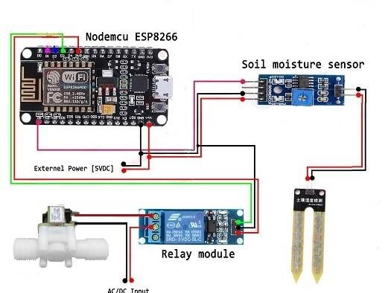

*Figure 30:Circuit diagram of Auto irrigator*

**Connecting Soil Moisture Sensor**

To power the soil moisture sensor module using the ESP8266, connect the 3.3V pin on the ESP8266 board to the VCC pin on the sensor. Similarly, connect the GND pin on the ESP8266 board to the GND pin on the sensor. Next, establish a connection between the soil moisture sensor's analog output (marked as AO) and the ESP8266 board's analog input, specifically the A0 pin. It's important to note that the DO pin on the soil moisture sensor should be left unconnected in this setup. This configuration ensures that the soil moisture sensor is appropriately powered and its analog output is connected to the ESP8266's analog input for reading soil moisture levels.

### 3.3.2 Single Axis Solar Tracking and Power Backup System

Single-axis solar tracking systems align themselves with the sun's movement along a single axis, either vertically or horizontally. Typically, their inclination angle is manually adjusted periodically throughout the year, while automated movement occurs in the east-west direction using IR sensor. These systems are economically advantageous compared to their two-axis counterparts but yield lower efficiency gains. Depending on solar trajectories and weather conditions, single-axis solar tracking systems pivot around either the vertical or horizontal axis.

**Materials**

* TDA2822 IC
* LDR Sensor
* 220R Resister
* 1N4007 Diode
* Solar panel
* Battery

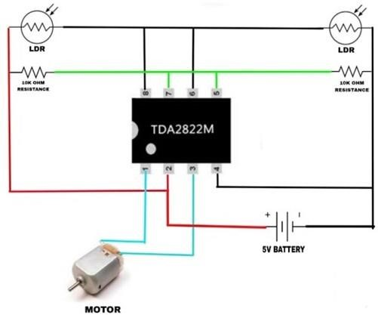

*Figure*  *31: Solar Tracker circuit diagram*

### 3.3.3 Gas Leak Detecting and Exhaust System.

The primary objective of this smart home system is to enhance safety and reduce accidents caused by gas leakage. The system incorporates an MQ-2 gas sensor, which effectively detects the presence of gas in the kitchen area. When gas is detected, LED indicators and a buzzer are activated to provide immediate visual and audible alerts to occupants. Simultaneously, the smart exhaust fan is automatically triggered to swiftly remove the gas, preventing any potential hazards. To offer remote monitoring and realtime updates, a dedicated mobile application is utilized, enabling users to check the gas status from anywhere in the world. Furthermore, in case of a gas leak, the mobile application promptly sends notifications, ensuring that users are alerted promptly to take necessary action and maintain a safe environment within their smart homes.

**Materials**

* ESP8266 module
* Power supply for ESP8266
* MQ-2
* Exhaust fan
* buzzer
* Led
* resistors
* Jumper wires
* Relay module

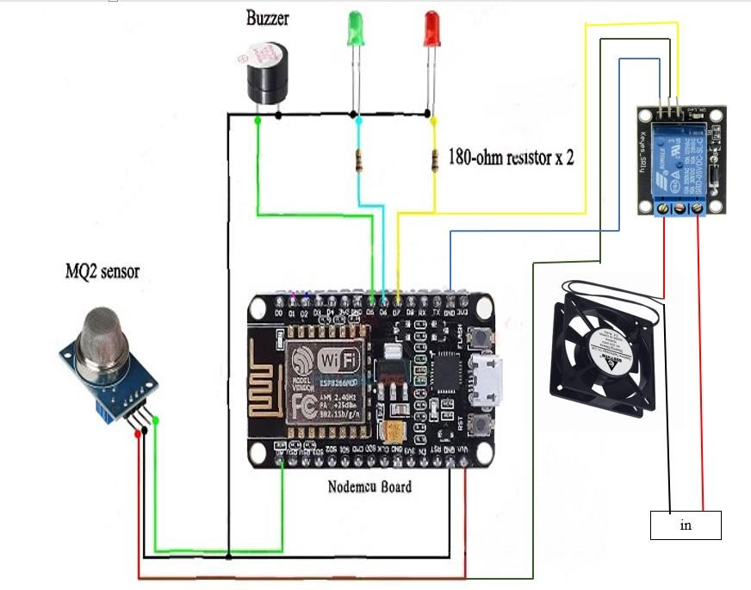

*Figure 32: Gas detector circuit diagram*

### 3.3.4 Water tank monitoring and Supplying System

This setup involves the utilization of two solenoid valves, an ultrasonic sensor, and a relay module. The ultrasonic sensor functions to detect the water tank's current level, subsequently enabling the automatic control of the solenoid valves for filling or stopping the tank's water supply. One solenoid valve regulates the tank's water level, while the other can be remotely activated through a mobile application. The mobile application provides real-time visibility into the tank's water level, allowing users to monitor the status effectively and control one of the solenoid valves as needed.

**Materials**

* ESP8266 module
* Power supply for ESP8266
* Water pump
* 12c lcd display
* buzzer
* Led
* resistors
* Jumper wires
* Relay module

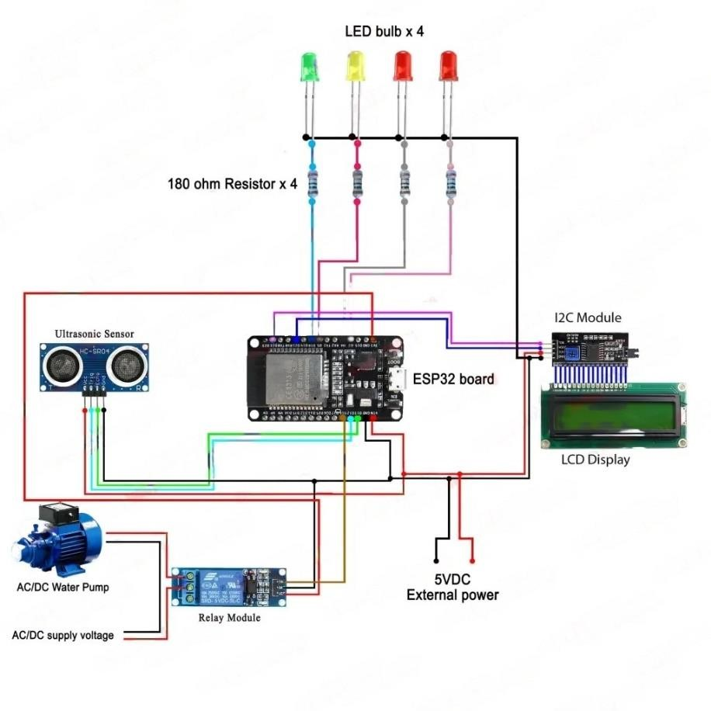

*Figure*

*33*

*:*

*Water level indicator circuit diagram*

### 3.3.5 Lighting, fan and power outlet controlling System.

This setup is designed to manage the activation and deactivation of lights and other devices. This can be accomplished either manually or through a smartphone or computer interface. Remarkably, this system extends its control capabilities to any location across the globe. The smart light control kit not only enables remote operation but also facilitates real-time monitoring of the power socket, bulb’s, fan and other power consuming status via a dedicated mobile application and node red database.

To enhance usability, a light-blocking sensor is incorporated to interpret the inputs from the manual switch. This sensor aids in capturing the switch's activity, whether it's being toggled on or off. In tandem, a pair of relays is employed to establish a two-way switch functionality. This technique serves a dual purpose: enabling control via the mobile application and accommodating traditional manual control through the switch. This setup is distinguished by its seamless integration of manual and digital control methods, granting users the freedom to interact with the lighting system using their preferred approach. Additionally, the system's global accessibility amplifies its convenience, empowering users to manage their lighting needs regardless of their location.

**Materials**

* ESP8266 module
* Power supply for ESP8266
* Bulb
* fan
* Jumper wires
* 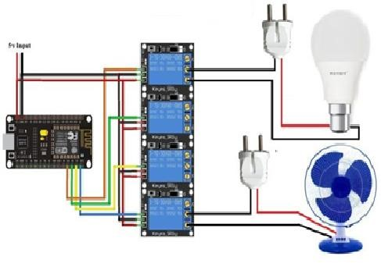Relay module

*Figure 34: Smart device controller circuit diagram*

### 3.3.6 Hazard detection, protection and Smart Security System

This system serves as a vigilant presence for identifying intrusions within contemporary residences. It leverages a PIR (Passive Infrared) sensor in conjunction with a buzzer to swiftly detect unauthorized movement within the smart home framework. This combined setup not only discerns such activities but also promptly triggers an alarm, generating an audible alert to draw attention to the potential breach.

In a fire alarm system, when the flame detector detects a fire hazard, it immediately sends a signal to the ESP8266 microcontroller. The ESP8266, acting as the central control unit, plays a critical role in ensuring the safety of individuals during a fire emergency. Upon receiving the signal, the ESP8266 processes the information and triggers an electronic lock mechanism to automatically unlock the door. This rapid response is crucial in providing a swift and safe exit route for occupants, protecting them from the dangers of a fire accident. Additionally, the system can be enhanced with additional features, such as sending notifications to responsible authorities or building occupants, activating alarms, and integrating with building management systems for a more comprehensive and proactive approach to fire safety. These vital details emphasize the importance of a well-coordinated fire detection and response system in safeguarding lives and property in emergency situations. Incorporating these considerations into a flame detector system with an ESP8266-controlled electronic lock can significantly enhance fire safety, protect lives, and minimize the potential risks associated with fire emergencies.

**Materials**

* ESP8266 module
* Power supply for ESP8266
* PIR Sensor
* 12v electronic door lock
* Flame detector
* buzzer
* Led
* resistors
* Jumper wires

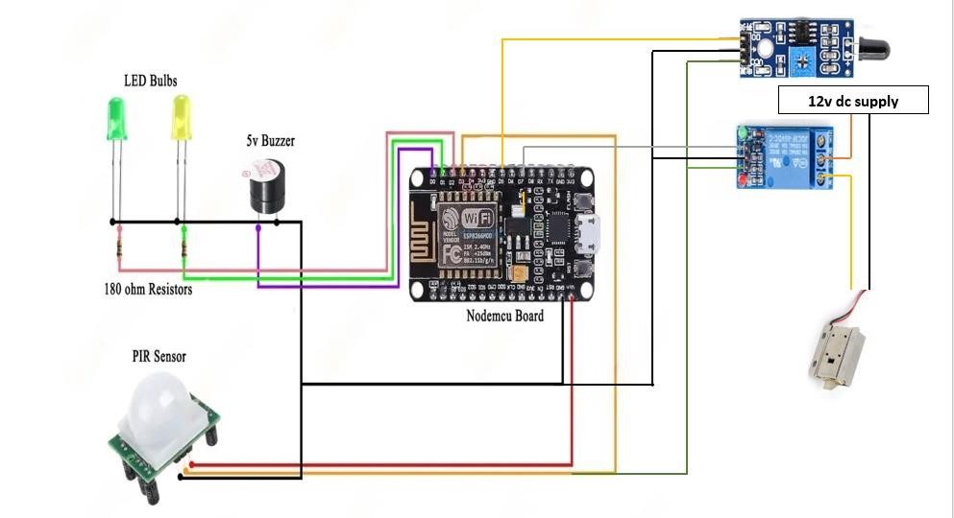

*Figure 35: Motion detector circuit diagram*

### 3.3.7 Energy Meter with data collecting and monitoring system

In the dynamic landscape of smart technologies, the Internet of Things (IoT) has emerged as a transformative force, revolutionizing the way we interact with and manage various aspects of our daily lives. One remarkable application of IoT lies in the realm of energy management, where innovative solutions are being developed to enhance efficiency and sustainability. This introduction delves into the world of IoTenabled energy meters, specifically focusing on a cutting-edge implementation using the ESP8266 microcontroller.

The ESP8266, renowned for its low-cost and high-performance characteristics, serves as the heart of our IoT energy meter. This compact and versatile microcontroller, equipped with built-in Wi-Fi capabilities, opens up new possibilities for remote monitoring and control of energy consumption. As energy conservation becomes an increasingly critical concern, the integration of ESP8266 into energy meters provides a scalable and cost-effective solution for both residential and industrial applications. In this exploration, we will unravel the key components and functionalities of our IoT energy meter, shedding light on how it leverages the ESP8266 to gather real-time data, communicate seamlessly with the internet, and empower users with actionable insights into their energy usage patterns. The marriage of IoT and ESP8266 not only ensures data accuracy but also facilitates real-time analysis, enabling users to make informed decisions about energy consumption, optimize resource allocation, and contribute to a more sustainable future.

**Components Required**

* ESP32 WiFi Module
* ZMPT101B AC Voltage Sensor Module
* SCT-013-030 Non-invasive AC Current Sensor
* Resistor 100-ohm, 10 K
* Capacitor 10uF
* 220V AC – 5V DC Power supply

**Connection Diagram**

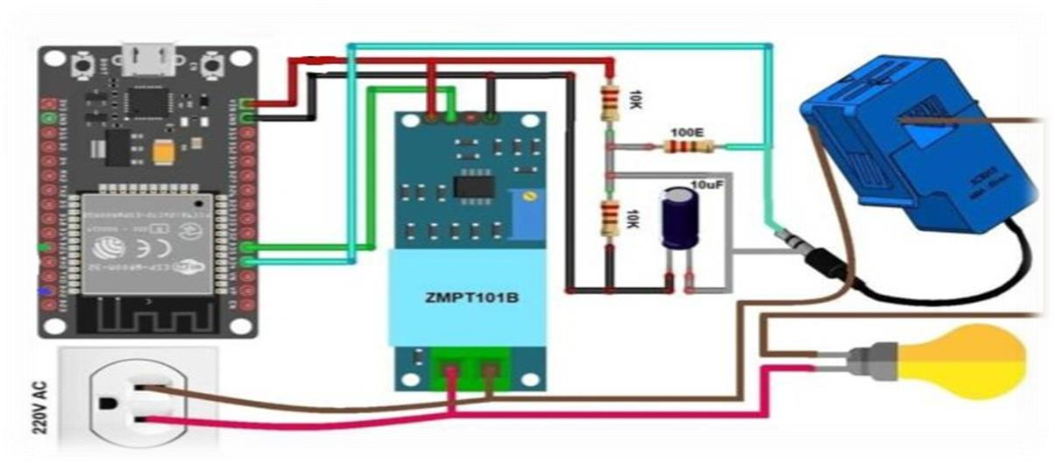

*Figure 36 : Energy Meter circuit diagram*

**Circuit Diagram & Hardware Setup**

The connection diagram is simple. Both the Sensor, SCT-013 Current Sensor & ZMPT101B Voltage Sensor VCC is connected to Vin of ESP32 which is a 5V Supply. The GND pin of both the modules is connected to the GND of ESP32. The output analog pin of the ZMPT101B Voltage Sensor is connected to GPIO35 of ESP32. Similarly, the output analog pin of SCT-013 Current Sensor is connected to GPIO34 of

ESP32. You need a two resistor of 10K & a single resistor of 100 ohms connected along with a 10uF Capacitor. Apart from the circuit part, the AC wires where the current and voltage needs to measured are connected to the input AC Terminal of

Voltage Sensor. Similarly, the current sensor clip doesn’t have any connection and a single live wire or neutral wire is inserted inside the clip part as shown in the above circuit.

**Setting Up node red database**

node red is a database that runs overcomputers and mobile web  devices to control any IoT based application using Smartphones or computers. It allows you to create your Graphical user interface for IoT application. Here we will display the IoT Energy Meter Data on node red Application.

1. From the dashboard create a new project and select ESP32 & Wifi Connection.
2. Then drag & drop or add 4 widgets and assign the variable.
3. Assigning and setup to google excel sheet

Finally, you can select your ESP32 board and the communication port, and click on the upload button. And don’t forget to change your SSID and password. If you can’t see your ESP32 board in the Arduino IDE boards list; it means your ESP32 board is not installed. For this you can read my getting started article on the [ESP32.](https://www.electroniclinic.com/esp32-arduino-ide-board-manager-installation-espressif-esp32-wroom/)

# CHAPTER 4

**RESULTS AND DISCUSSION**

## 4.1 Chapter Introduction

This section delves deeply into the outcomes of the study and engages in comprehensive discussions based on the results obtained. It thoroughly scrutinizes the conclusions drawn from the experimentation process and the subsequent development of the mechanism. The discourse encompasses a meticulous exploration of the findings, delving into their implications, and elucidates the significance and possible applications of the system that has been created.

## 4.2 Result and Discussion

The Smart home controller comprises seven separate subsystems that can be easily integrated into homes, allowing for the development of a highly user-friendly experience. All these systems are designed to connect to a NODEMCU, a versatile platform with Wi-Fi and Bluetooth capabilities. The NODEMCU's advantage lies in its efficient power consumption compared to other controllers, making it an optimal choice for this application with its 3V output voltage. However, as the NODEMCU's 3V output voltage is insufficient for directly managing 220V home circuits, a relay module is employed to bridge the gap. This relay module serves as the interface between the low-voltage NODEMCU and the high-voltage 220V home circuits, enabling seamless and safe control.

All the systems can control easily using user friendly interface of mobile or computer interface and also can monitoring systems operations. Sometimes controller faces small delay to control those systems. Controller can reduce that delay using high speed internet connection.

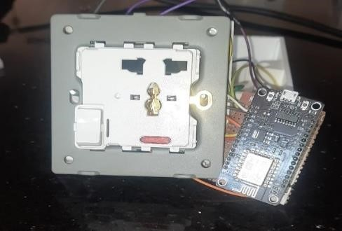

*Figure 37 : WIFI controlled socket outlet*

The MQ-2 gas sensor is specifically designed to detect gases such as LP, methane, propane, and butane. It excels in identifying these gases accurately. However, it's important to note that the MQ-2 sensor is not suitable for detecting smoke, acetylene, or other gases. Our primary application for the MQ-2 gas sensor is to efficiently identify and alert us about potential LP gas leaks.

When smoke is detected, the system automatically triggers the alaram and exhaust fans and ventilation equipment to expel the smoke and maintain air quality, thereby protecting occupants from potential fire hazards and ensuring a safe and breathable environment. This integrated approach to fire safety and air quality control is essential in preventing disasters and safeguarding public spaces.This crucial information is then communicated to a mobile application and notered database for timely and convenient notifications.

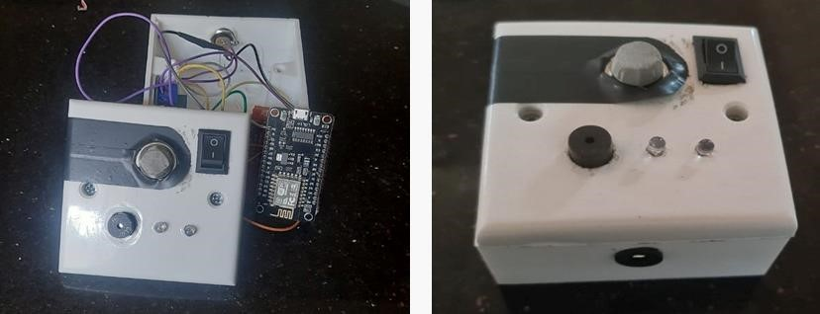

*Figure 38 :Portable Gas Detector & Inside parts*

Within the security system, involved the development of an advanced security system for contemporary residences and a fire alarm system integrated with an ESP8266 microcontroller. In the security system, a Passive Infrared (PIR) sensor was utilized in tandem with a buzzer to swiftly identify unauthorized intrusions within a smart home environment. This combination not only effectively detected suspicious activities but also triggered an immediate audible alarm to alert residents or security personnel.

In the fire alarm system, a flame detector played a pivotal role in identifying fire hazards. Upon detection, the flame detector promptly sent a signal to the central control unit, an ESP8266 microcontroller. The ESP8266 then processed this information and initiated an electronic door lock mechanism, facilitating a quick and safe exit route during a fire emergency. This rapid response is crucial in ensuring the safety of individuals in such situations.

Furthermore, the system's capabilities can be expanded by integrating additional features, including notifications to responsible authorities or building occupants, activation of alarms, and integration with building management systems, offering a more comprehensive and proactive approach to fire safety. The successful integration of these technologies highlights the significance of a well-coordinated security and fire detection system in safeguarding lives and property during security breaches and fire emergencies. By implementing a flame detector system with an ESP8266-controlled electronic lock, this project demonstrates the potential to significantly enhance safety, protect lives, and mitigate the risks associated with such critical events.

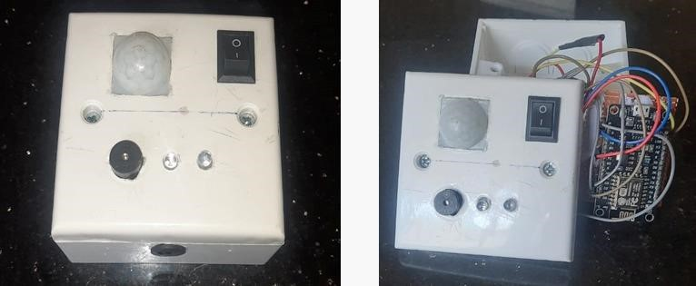

#### *Figure 39: Portable Motion Detector & Inside parts*

Modern Smart home controller lightning, fan, power socket system can control using interface only. Because of that reason we develop switch using two relay modules. In our system can control using both switch and mobile application and node red database.

Unlike the prevailing expensive options in modern home technologies, our systems offer a budget-friendly alternative without compromising on accuracy. Our Smart home controller control kit boasts remarkable cost-effectiveness while maintaining a high level of precision. Remarkably, this kit is designed for global applicability, ensuring its usability in various settings across the world.

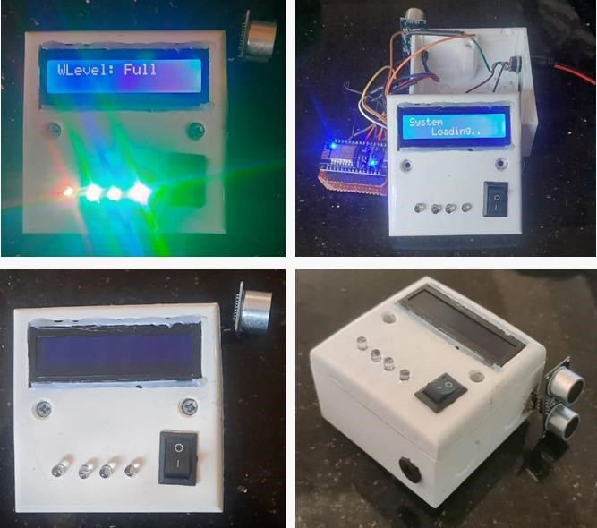

*Figure 40: Ultrasonic water level indicator with display*

Mobile phones and computerized enables users to monitor and control soil moisture and water level sensors linked to the ESP8266 board. Users can access real-time data from these sensors, ensuring they stay informed about their plant's environment. The nodered also allows customization of the system's behaviour. Automatic watering can be toggled on/off, with automatic mode being the default. In automatic mode, the ESP8266 manages watering by considering water tank levels and soil moisture. If conditions warrant, it waters the plant. Users can alternatively switch to manual control. Here, they take charge of watering by pressing a button in the app. Users can choose automated or manual watering, all within an efficient gardening experience.

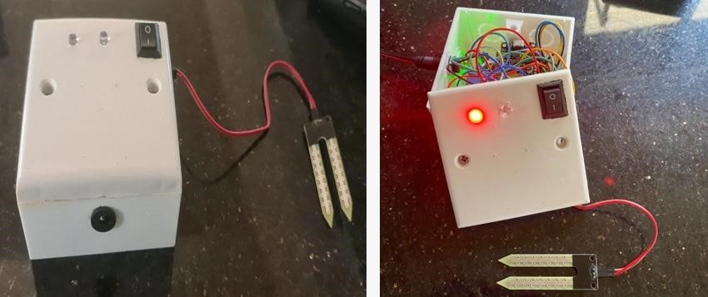

#### *Figure 41: Portable automatic plant irrigator*

Single-axis solar tracking systems are designed to align with the sun's movement along one axis, which can be either vertical or horizontal. While these systems are economically favourable compared to two-axis alternatives, their efficiency gains are somewhat reduced. The choice between vertical and horizontal axis rotation depends on solar trajectories and prevailing weather conditions.

Throughout the project's duration, we encountered several challenges. Delays in certain operations arose due to equipment shortages. Some sensors and devices were unavailable in the local market due to the prevailing situation in Sri Lanka. Additionally, escalating material prices posed a hurdle. To overcome these obstacles, we resorted to using standard electronic devices. For instance, we opted for a regular ultrasonic sensor due to the elevated cost of waterproof ultrasonic sensor modules. The existing circumstances in our country present a significant challenge in achieving a flawless 100% result for our project.

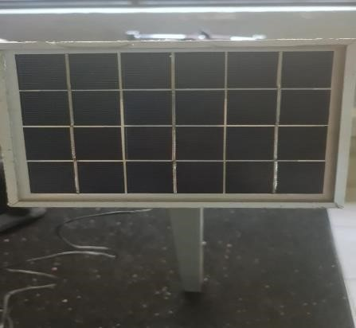

*Figure 42 : Backup solar for smart home*

In energy meter. The ESP8266, with its low cost and Wi-Fi capabilities, serves as the central processing unit for data collection, processing, and communication. The ZMPT101B AC Voltage Sensor Module and SCT-013-030 Non-invasive AC Current Sensor enable the meter to accurately measure both voltage and current, essential for calculating power consumption. The 100-ohm and 10K resistors, along with the 10uF capacitor, are used in sensor signal conditioning. The 220V AC to 5V DC power supply ensures the system's proper functioning.

One of the most significant advantages of this IoT energy meter is its ability to provide real-time and accurate data on energy consumption. The integration of the ESP8266 microcontroller allows for continuous monitoring and data collection, which can be instantly transmitted to the cloud or a local server for analysis. This real-time data is essential for tracking energy usage patterns, identifying spikes and making informed decisions regarding energy management. The built-in Wi-Fi capabilities of the ESP8266 microcontroller enable remote monitoring and control of the energy meter. Users can access their energy consumption data from anywhere with an internet connection, providing them with a convenient way to keep tabs on their usage, even when they are away from home or the industrial site. This remote access also enables users to control and optimize energy-consuming devices or systems remotely, contributing to better energy efficiency.

The ESP8266 microcontroller is renowned for its cost-effectiveness, making it a practical choice for both residential and industrial applications. The ability to integrate this technology into existing energy meters or install it in new setups provides a scalable solution that can be tailored to various needs. This scalability is crucial in addressing the diverse requirements of residential households, commercial buildings, and industrial facilities. By providing users with real-time data and analysis of their energy consumption patterns, this IoT energy meter empowers them to make informed decisions about energy usage. This, in turn, contributes to a more sustainable future by promoting energy conservation and efficiency. Users can identify energy wastage, optimize resource allocation, and reduce their carbon footprint. While the IoT energy meter using the ESP8266 offers numerous benefits, it's essential to consider some challenges and potential issues. These may include the need for a stable internet connection, data security and privacy concerns, and the initial setup and configuration complexities. Ensuring data security is of paramount importance to protect user information and prevent unauthorized access to the system.

The auto current billing system can be implemented by programming the ESP8266 to calculate energy consumption based on the data received from the voltage and current sensors. By integrating the energy consumption calculation into the microcontroller, users can be billed automatically, eliminating the need for manual meter readings. The system's ability to transfer data to Google Sheets provides users with an organized and accessible platform for data analysis and visualization. This integration enables users to keep track of their energy consumption patterns and allows service providers to manage billing effectively.

the IoT energy meter using the ESP8266 microcontroller is a groundbreaking solution for energy management, offering real-time data, remote access, cost-effectiveness, and sustainability benefits. It has the potential to revolutionize the way we interact with and manage our energy consumption, enabling us to make informed decisions and contribute to a more sustainable future. However, it's crucial to address challenges and ensure that privacy and security are adequately safeguarded in such systems.

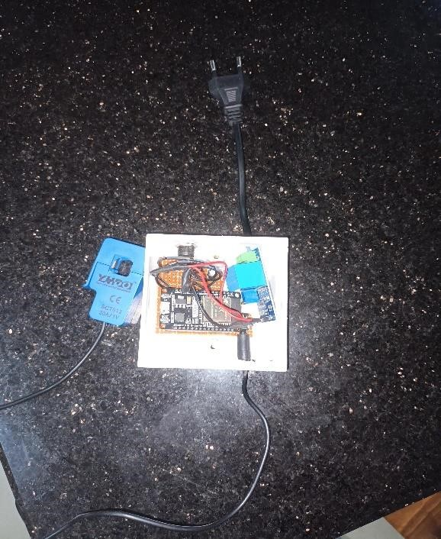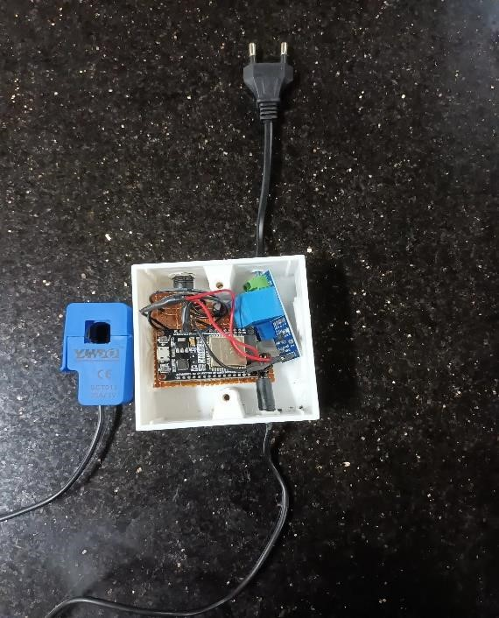

*Figure 43 : Energy meter setup*

# CHAPTER 5

**CONCLUSIONS AND RECOMMENDATIONS**

## 5.1 CONCLUSIONS

The primary aim of this project was to develop and practically implement a comprehensive smart home system while overseeing its auxiliary functionalities and efficient small building management for house. This objective has been successfully achieved through the utilization of NODEMCU and smart monitoring and control integration. The resulting system encompasses various features such as an automated irrigation system, gas detection with auto exhaust capabilities, solar tracking with power backup, a fire detection and protection with smart door system, intelligent lighting, gas leak detection, home security, water management, data recording, monitoring and control system.

This study marks a significant milestone in the pursuit of creating an accessible, userfriendly, and dependable smart home system. It establishes the foundation for a future where such systems can become affordable and widely accessible. The study's findings support the assertion that advancements in technology have enabled cost-effective upgrades to systems that necessitate minimal maintenance efforts. Upon testing the prototype, it was evident that the system's operation was intuitive and user-friendly. Furthermore, the prototype's adaptability for accommodating new devices that are both reliable and economically feasible was highlighted. This reaffirms the potential for integrating devices onto the system that are not only trustworthy but also scalable for future enhancements. This research signifies the transformative potential of technology to reshape conventional systems, making them more efficient, convenient, and adaptable to changing needs.

Once the prototype is introduced to the market, the intention is to reduce the price, making it accessible to a wider audience, particularly in developing nations. Rigorous system testing encompassing both hardware and software has been employed to ensure the overall integration's alignment with its specific requirements. As a result, each stage proceeded seamlessly.

Importantly, this research offers valuable insights and learnings that can be carried forward into future investigations. The prototype of this system has been deliberately designed to be uncomplicated, affordable, and user-friendly. However, there is room for further enhancement and development to ensure the system's optimal performance.

Some of these enhancements encompass:

* Using other technologies, such as Wi-Fi and Zigbee, for communication between the system and user interface.
* Instead of relying just on Android apps, develop a app so that the system can be utilized with any sort of mobile phones and computers.
* Add extra PIR, flame detector module sensors to the mix.
* To display the motion and power consumption, add another screen to the app.
* AC relay usage and real-world system testing.
* Controlling the doors with a magnetic sensor as opposed to a servo motor

Students will be able to develop a system on their own that ensures efficiency in controlling smart home technologies, as well as security, comfort, economy, and efficiency in managing their own homes. Students and instructors alike will benefit practically from the Mini Smart home controller project. It can be used to teach a variety of subjects in computer science and physics classes at schools.

## 5.2 RECOMMENDATIONS

1. Continuous development/improvement – Invest in the ongoing development and refinement of the smart home controller to ensure it remains compatible with emerging technologies and stays up-to-date with user needs.
2. Integration with more devices – Expand the smart home controller's compatibility with a wider range of devices, appliances, and systems to increase its appeal and functionality for potential users.
3. User-friendliness – Focus on improving the user interface and experience, making it more intuitive for all users, regardless of their tech-savviness. Clear, concise instructions and an easily navigable menu should be priorities.
4. Customization options – Offer more personalization options for individual users to tailor their smart home controllers according to their preferences, budget restrictions, or specific requirements.
5. Security enhancements – Strengthen encryption protocols and introduce multifactor authentication to boost system security, reassuring homeowners that they are investing in a reliable product without sacrificing safety measures.
6. Utility preservation – Maximize the energy-saving capabilities of the controller by incorporating additional sensors or algorithms to optimize power consumption patterns across devices.
7. Educational resources – Provide accessible resources in various mediums (videos, articles, webinars) for existing and prospective users to educate them on the full potential of the smart home controller system and its best practices.

By following these recommendations, the smart home controller system can maintain its relevance in the rapidly evolving home automation market and continue to offer users

### REFERENCES

Ahemed, R., & Amjad, M. (2019). Automated Water Managemenrt System (WMS).

Int J Educ Manag Eng, 9(3), 27-36.

Amraoui, N. E., & Rachidi, T. (2023). SMART HOME SECURITY SYSTEM.

Balakrishnan, S., Vasudavan, H., & Murugesan, R. K. (2018, December). Smart home technologies: A preliminary review. In Proceedings of the 6th International Conference on Information Technology: IoT and Smart City (pp. 120-127).

Dewsbury, G., Clarke, K., Rouncefield, M., Sommerville, I., Taylor, B., & Edge, M.

(2003). Designing acceptable ‘smart’home technology to support people in the home. Technology and Disability, 15(3), 191-199.

Fuada, S., Adiono, T., & Siregar, L. (2021). Internet-of-Things for Smart Street Lighting System using ESP8266 on Mesh Network. Int. J. Recent Contributions Eng. Sci. IT, 9(2), 73-78.

Gaikwad, P. P., Gabhane, J. P., & Golait, S. S. (2015, April). A survey based on Smart Homes system using Internet-of-Things. In 2015 International Conference on Computation of Power, Energy, Information and Communication (ICCPEIC) (pp. 0330-0335). IEEE.

Hui, T. K., Sherratt, R. S., & Sánchez, D. D. (2017). Major requirements for building Smart Homes in Smart Cities based on Internet of Things technologies. Future Generation Computer Systems, 76, 358-369.

Hassan, S. A., & Eassa, A. M. (2022). A Proposed Architecture for Smart Home Systems Based on IoT, Context-awareness and Cloud Computing. *International Journal of Advanced Computer Science and Applications*, *13*(6).

Jabbar, W. A., Kian, T. K., Ramli, R. M., Zubir, S. N., Zamrizaman, N. S., Balfaqih, M., ... & Alharbi, S. (2019). Design and fabrication of smart home with internet of things enabled automation system. IEEE access, 7, 144059-144074.

Kimbugwe, J., & Bowgo, J. K. D. (2016). Design and implementation of a remote control system of doors and lights using an android phone.

Minoli, D., Sohraby, K., & Occhiogrosso, B. (2017). IoT considerations, requirements, and architectures for smart buildings—Energy optimization and next-generation building management systems. *IEEE Internet of Things Journal*, *4*(1), 269-283.

Mowad, M. A. E. L., Fathy, A., & Hafez, A. (2014). Smart home automated control system using android application and microcontroller. International Journal of Scientific & Engineering Research, 5(5), 935-939.

Norarzemi, U. A. (2020, December 14). *Development Of Prototype Smart Door*

*System With IoT Application*.

<https://publisher.uthm.edu.my/periodicals/index.php/peat/article/view/259>

Paul, C., Ganesh, A., & Sunitha, C. (2018, January). An overview of IoT based smart homes. In 2018 2nd International Conference on Inventive Systems and Control (ICISC) (pp. 43-46). IEEE.

Parab, P., Kulkarni, M., & Shinde, V. (2018). Smart Locker Management System Using IoT. system, 8, 10.

Sharma, M., Tripathi, D., Yadav, N. P., & Rastogi, P. (2018). Gas leakage detection and prevention kit provision with IOT. Gas, 5(02).

Sattaru, P. K., Burugula, K. V., Channagiri, R., & Kavitha, S. (2023, January). Smart Home Security System using IoT and ESP8266. In 2023 5th International Conference on Smart Systems and Inventive Technology (ICSSIT) (pp. 469-474). IEEE.

Sangeetha, B. P., Kumar, N., Ambalgi, A. P., Haleem, S. L. A., Thilagam, K., & Vijayakumar, P. (2022). IOT based smart irrigation management system for environmental sustainability in India. *Sustainable Energy Technologies and Assessments*, *52*, 101973.

Sailaja, K., & Rohitha, M. (2018, April). Literature survey on real world applications using internet of things. In *2018 IADS international conference on computing, communications & data engineering (CCODE)*.

Vikram, N., Harish, K. S., Nihaal, M. S., Umesh, R., & Kumar, S. A. A. (2017, January). A low cost home automation system using Wi-Fi based wireless sensor network incorporating Internet of Things (IoT). In 2017 IEEE 7th International Advance Computing Conference (IACC) (pp. 174-178). IEEE.

Wenbo, Y., Quanyu, W., & Zhenwei, G. (2015, July). Smart home implementation based on Internet and WiFi technology. In 2015 34th Chinese Control Conference (CCC) (pp. 9072-9077). IEEE.

### APPENDICES

Appendix A–blender 3D model home

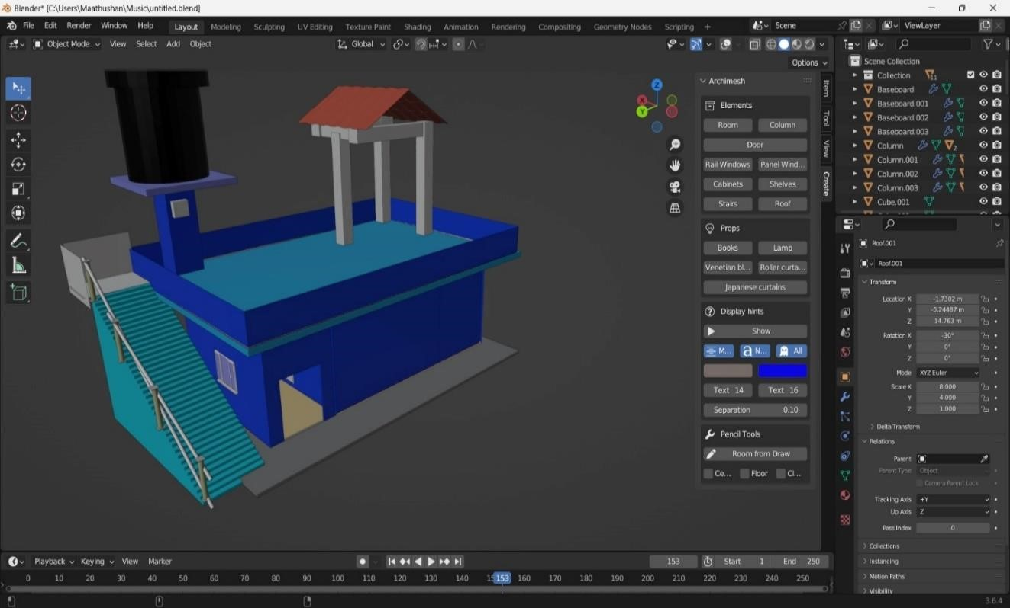

*Figure 40 : blender 3D model home front 01*



*Figure 41: blender 3D model home side 02*

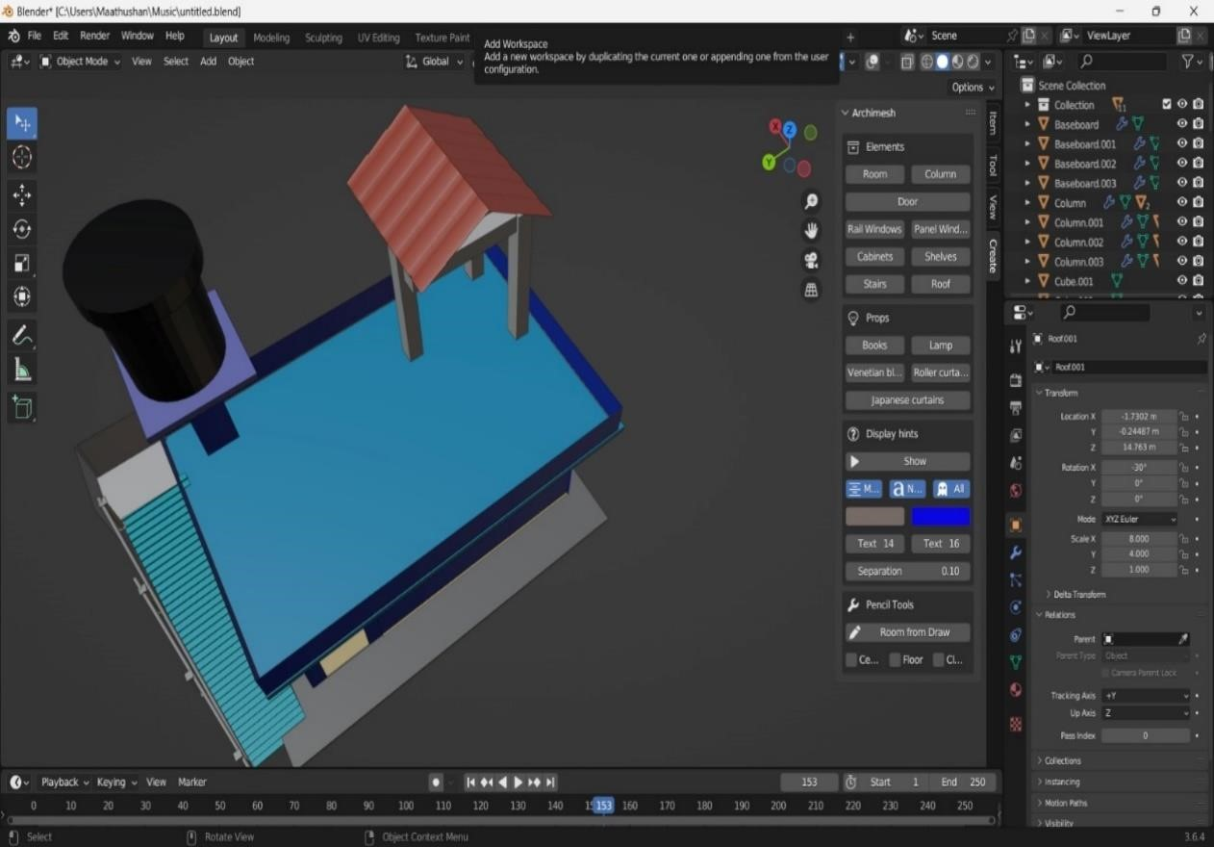

*Figure 42 : blender 3D model top -03*



*` Figure 43 : blender 3D model home front -04*



*Figure 44 : blender 3D model home -05*

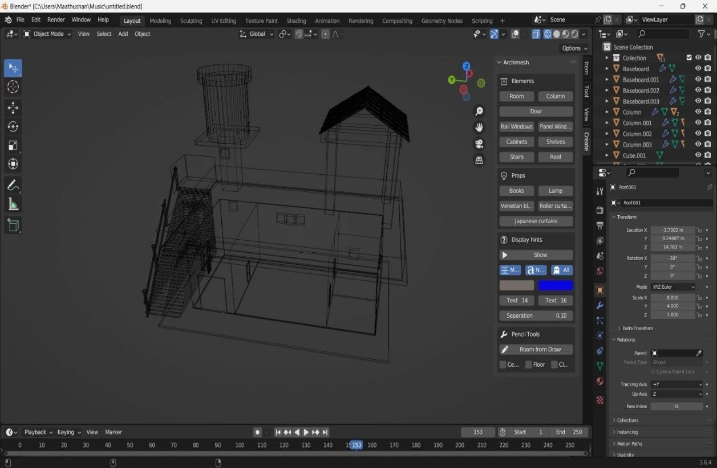

##### *Figure 45 : blender 3D model home -06*

**Appendix B– Arduino code**

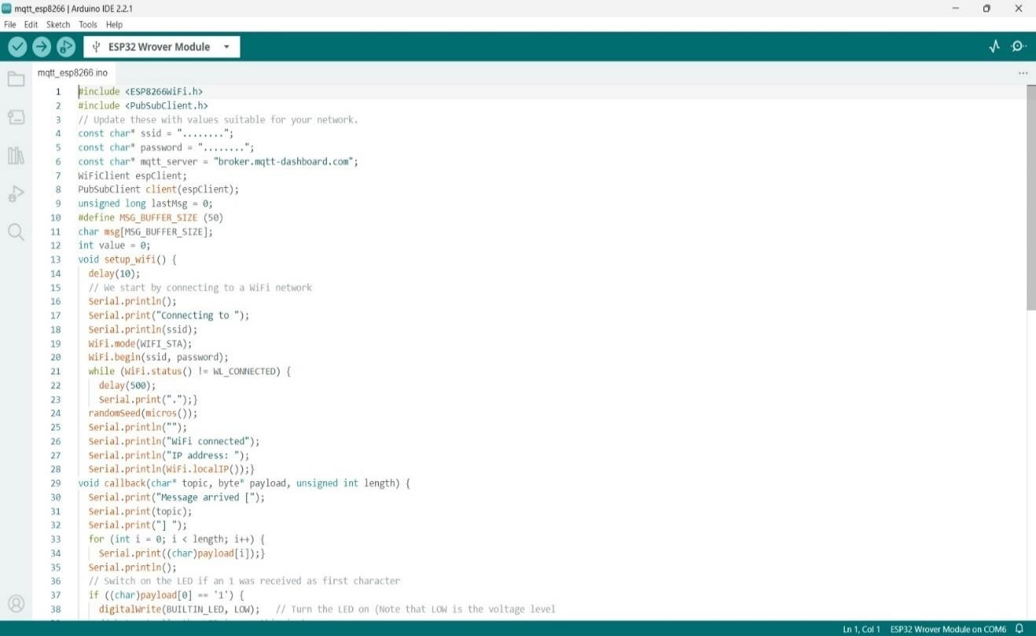

##### *Figure 46: MQTT web server Arduino code*

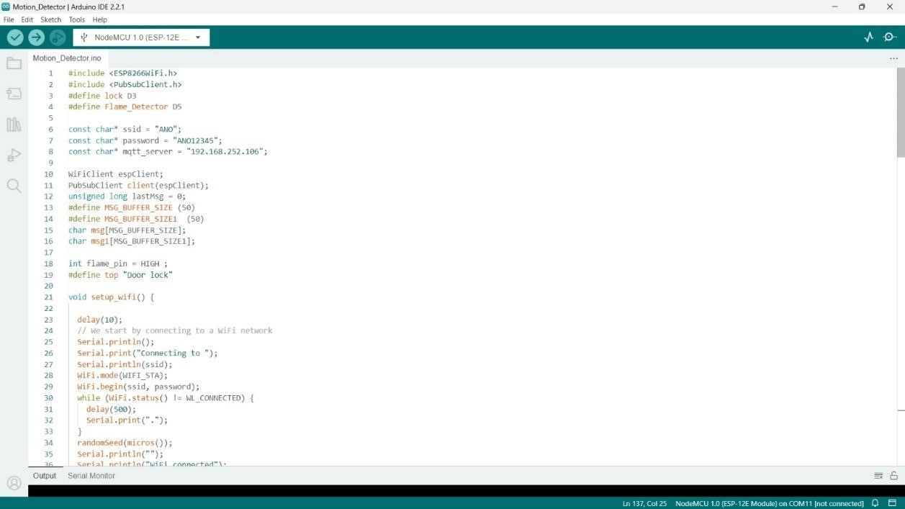

*Figure 47 : Motion detector Arduino code 01*

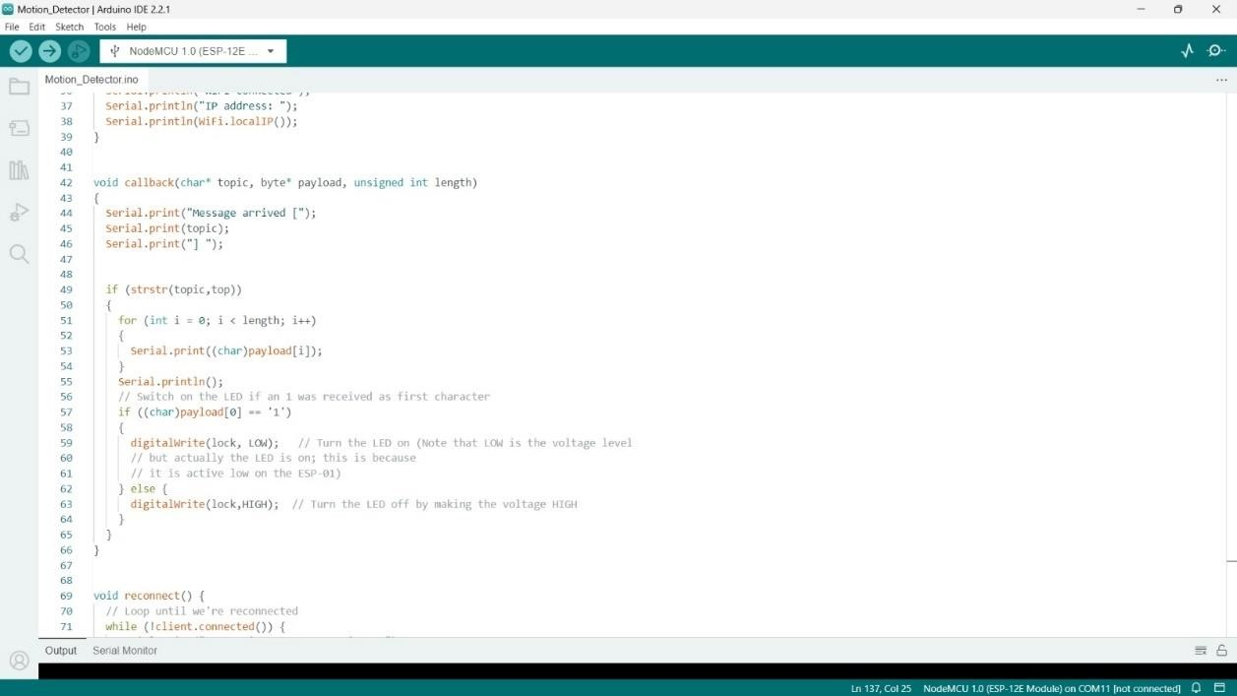

##### *Figure 48 : Motion detector Arduino code 02*

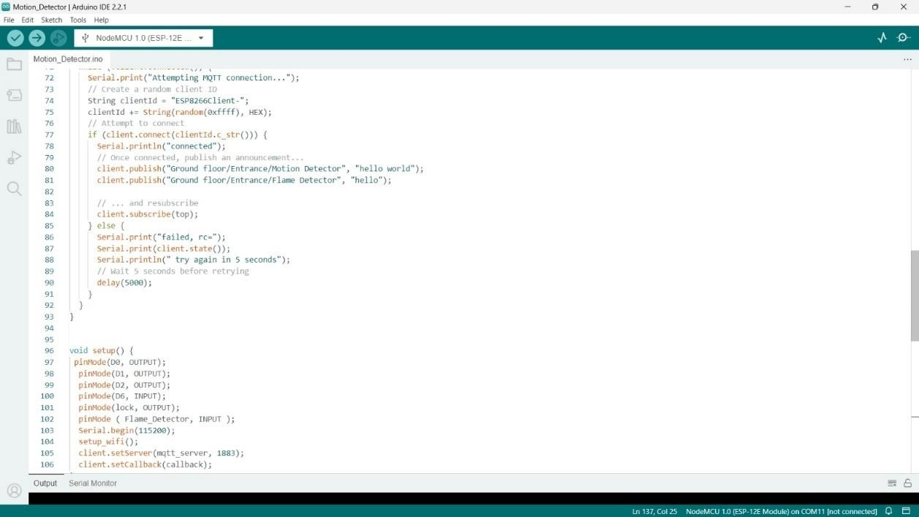

*Figure 49 : Motion detector Arduino code 03*

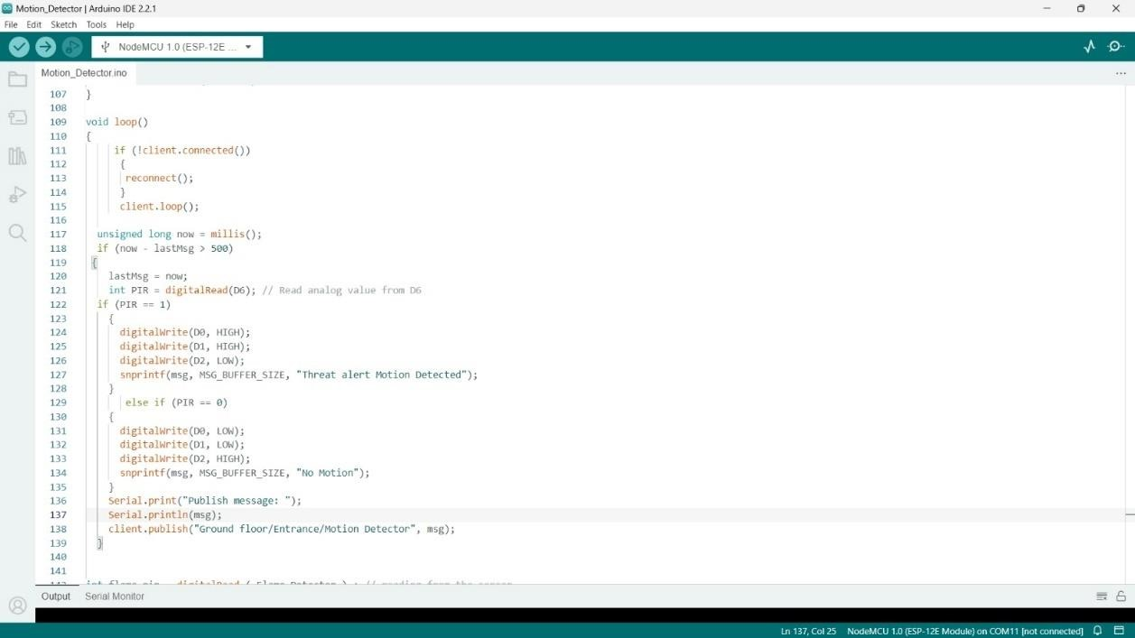

##### *Figure 50 : Motion detector Arduino code 04*

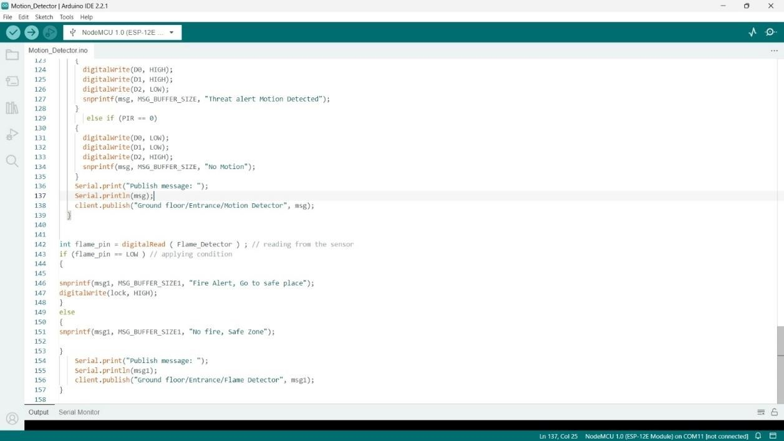

*Figure 51 : Motion detector Arduino code 05*

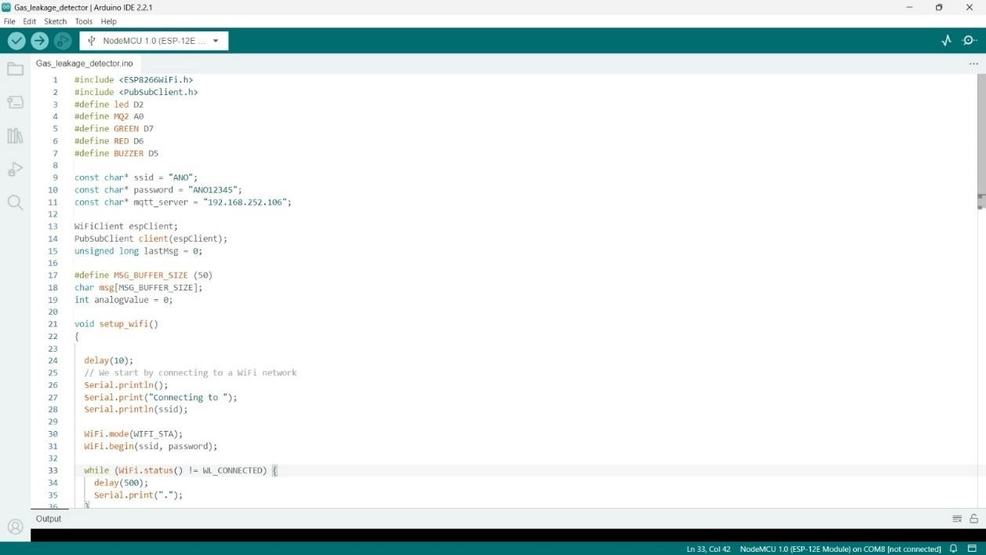

*Figure 52 : Gas leakage and auto exhaust system Arduino code 01*

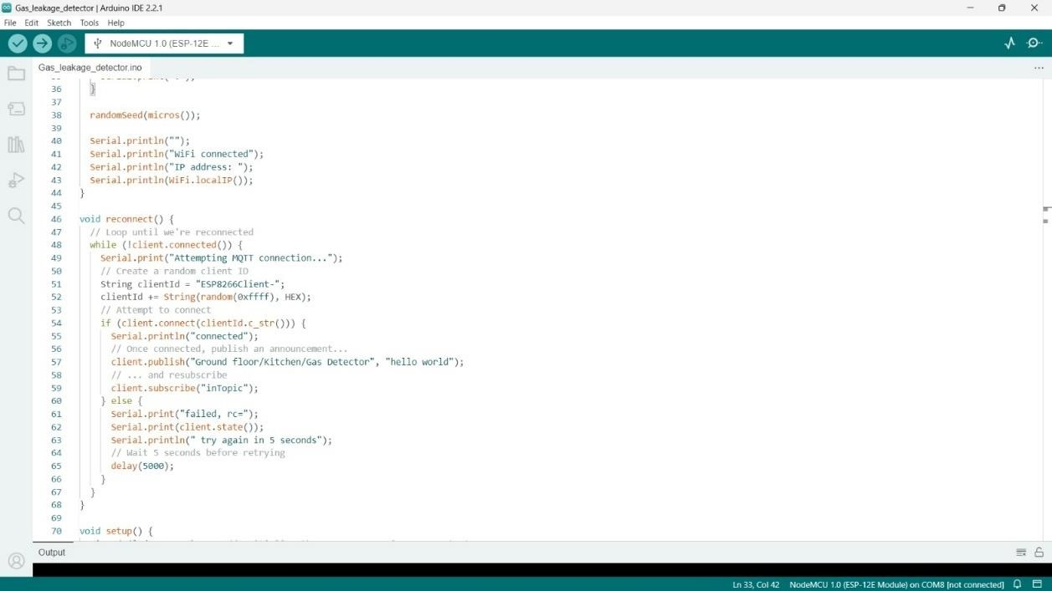

*Figure 53 : Gas leakage and auto exhaust system Arduino code 02*

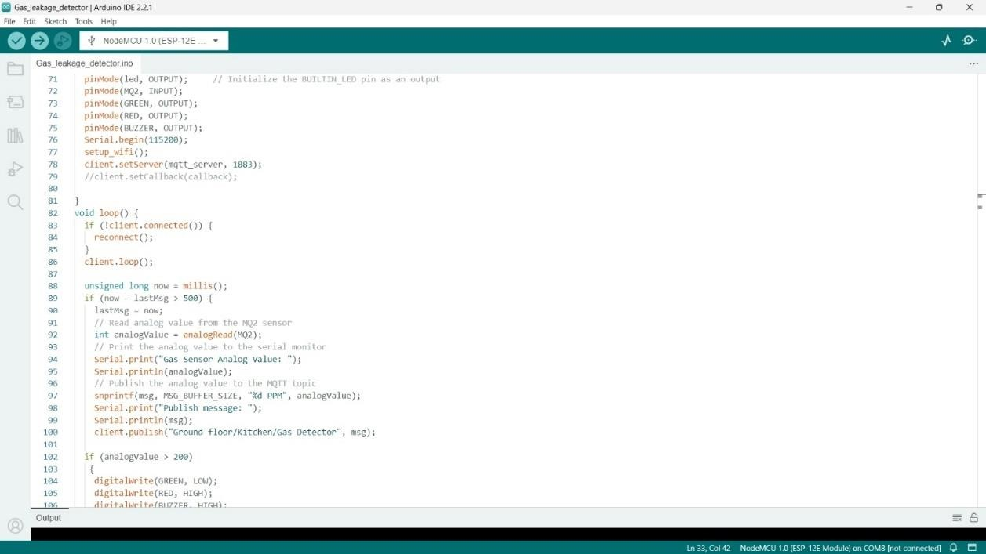

*Figure 54 : Gas leakage and auto exhaust system Arduino code 03*

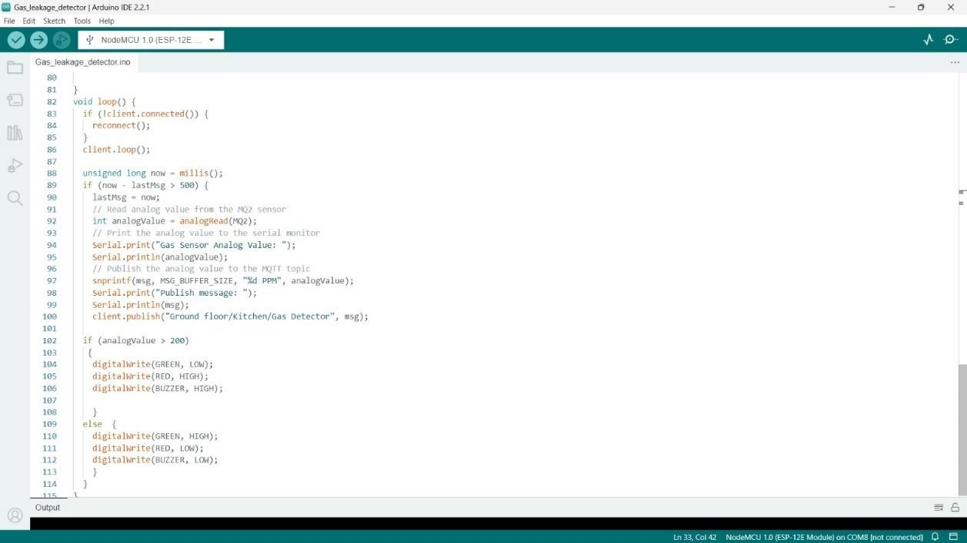

*Figure 55 : Gas leakage and auto exhaust system Arduino code 04*

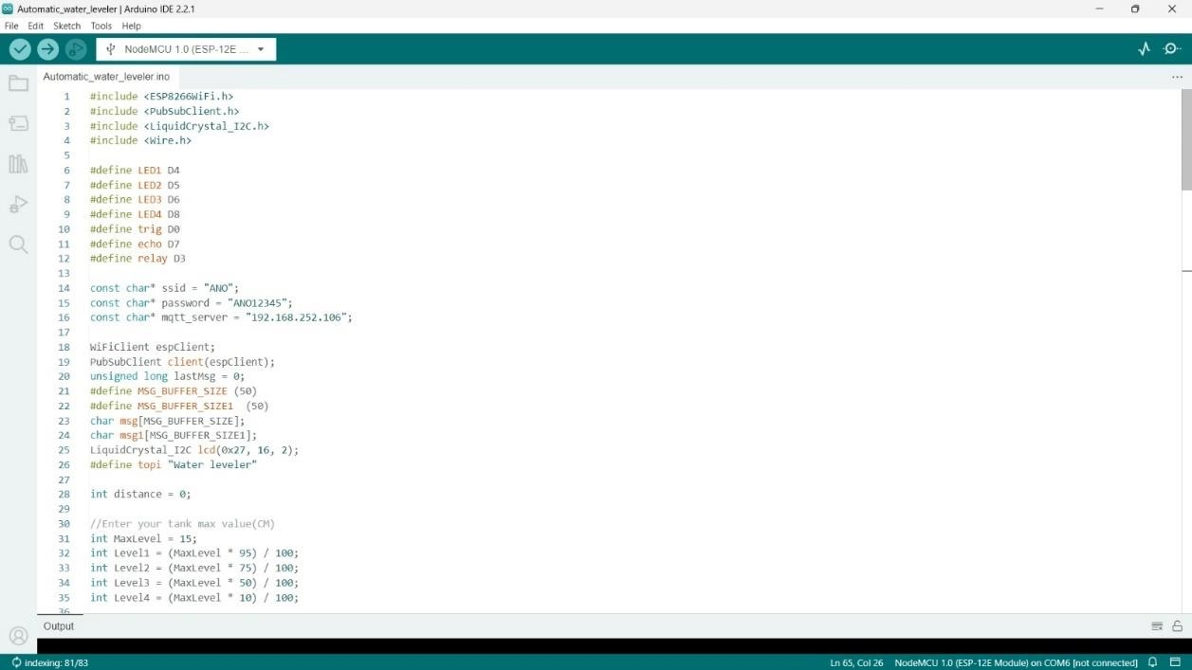

*Figure 56 : Automated water level monitoring and filling system Arduino code 01*

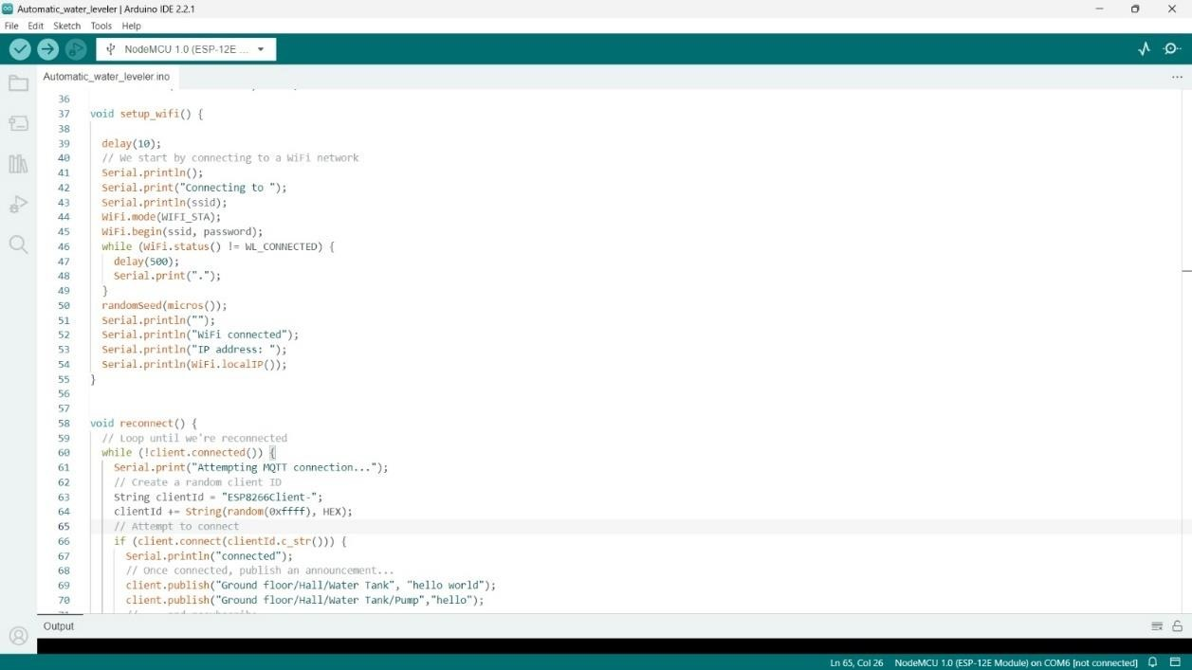

*Figure 57 : Automated water level monitoring and filling system Arduino code 02*

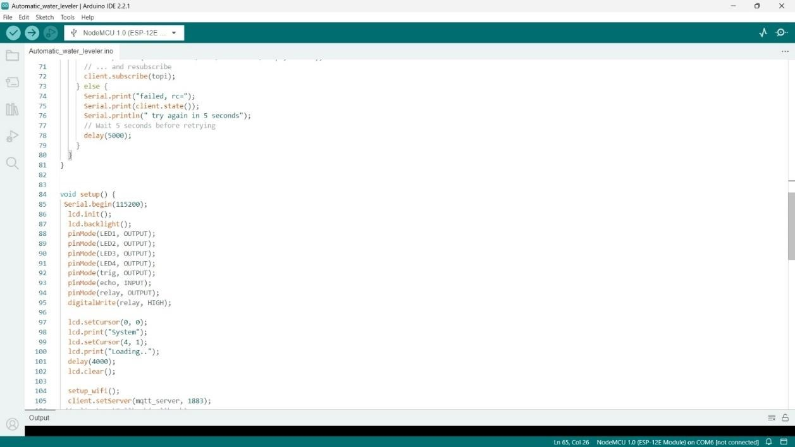

*Figure 58 : Automated water level monitoring and filling system Arduino code 03*

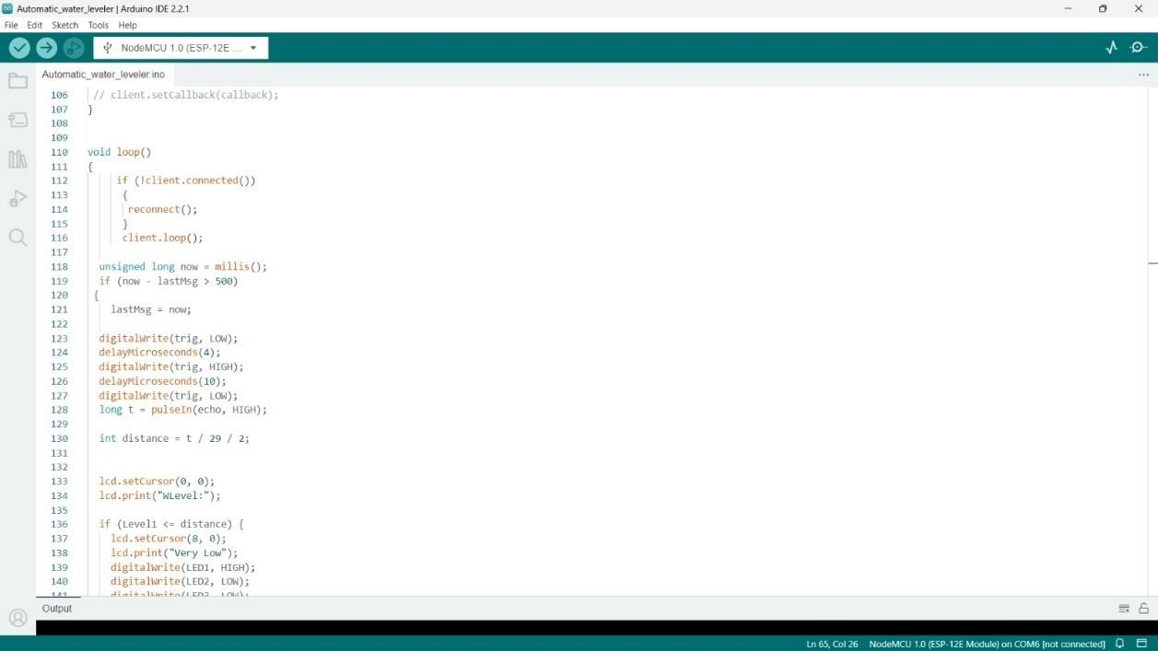

*Figure 59 : Automated water level monitoring and filling system Arduino code 04*

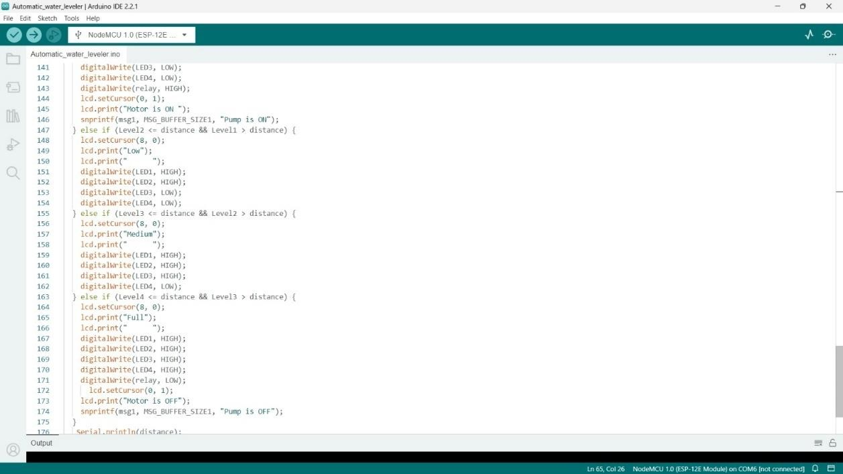

*Figure 60 : Automated water level monitoring and filling system Arduino code 05*

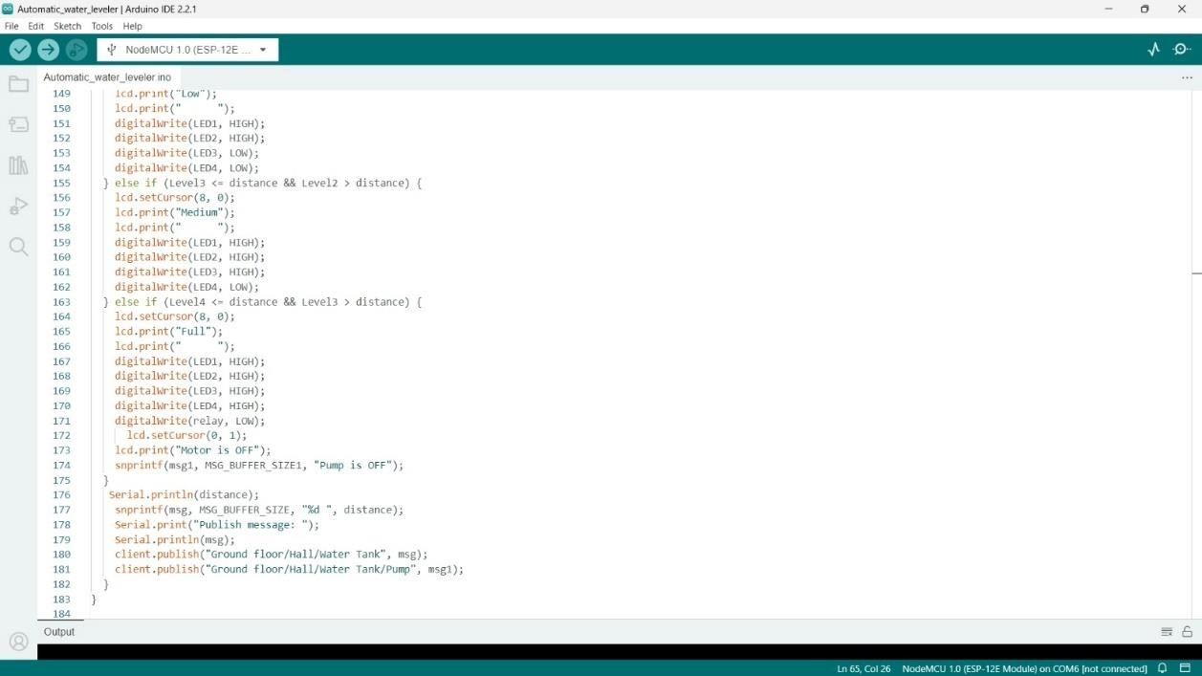

*Figure 61 : Automated water level monitoring and filling system Arduino code 06*

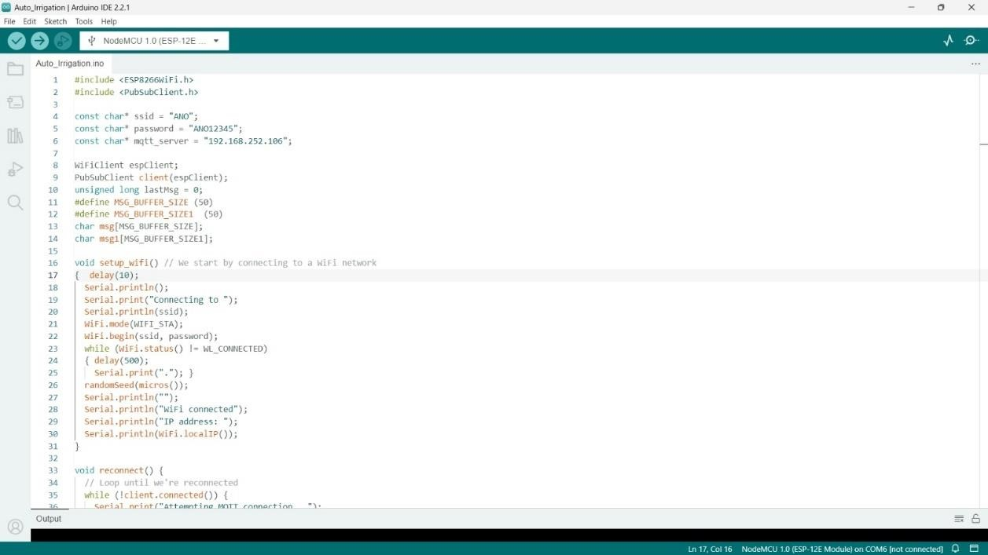

*Figure 62 : Auto irrigation system Arduino code 01*

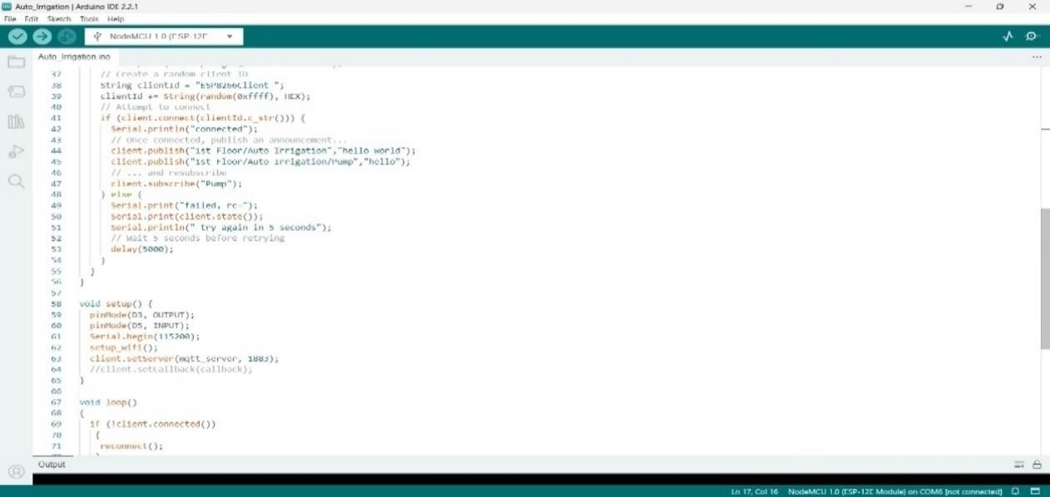

*Figure 63 : Auto irrigation system Arduino code 02*

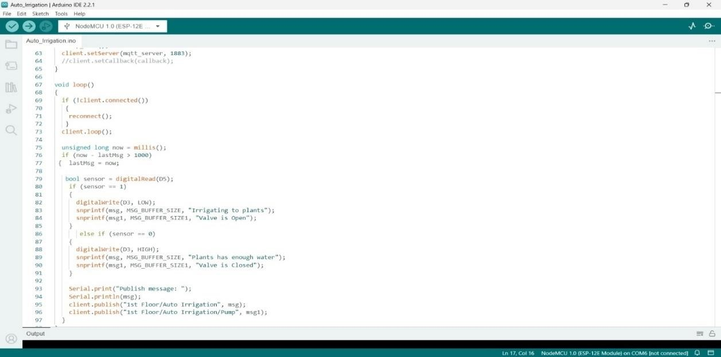

*Figure 64 : Auto irrigation system Arduino code 03*

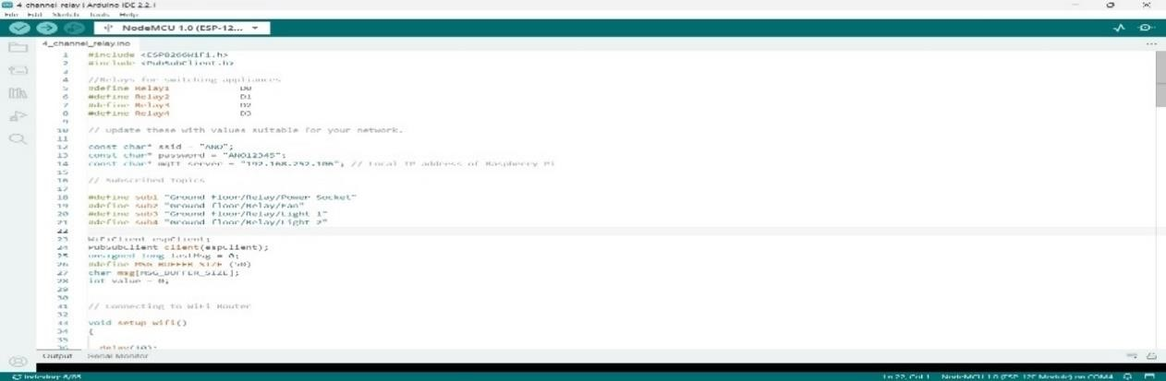

*Figure 65 : Wi-Fi controlled 4 channel relay Arduino code 01*

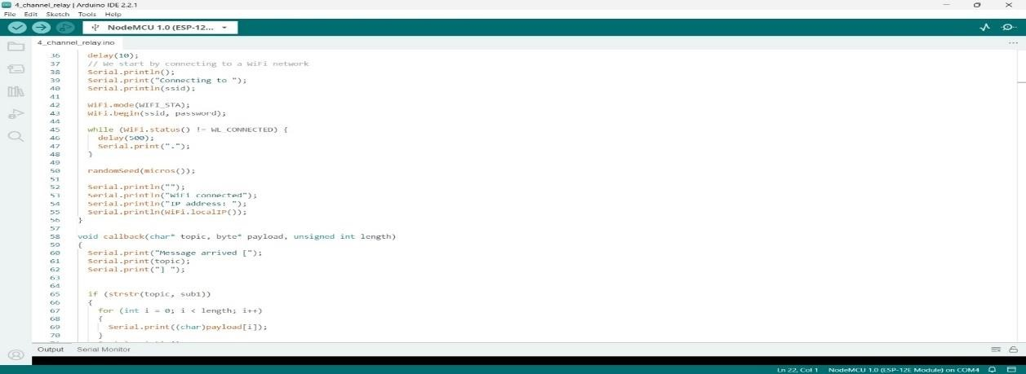

*Figure 66 : Wi-Fi controlled 4 channel relay Arduino code 02*

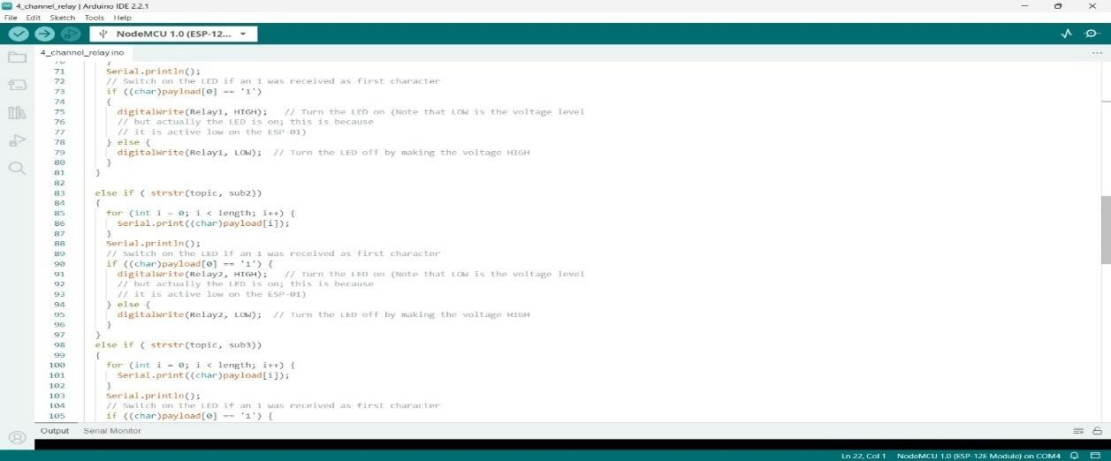

*Figure 67 : Wi-Fi controlled 4 channel relay Arduino code 03*

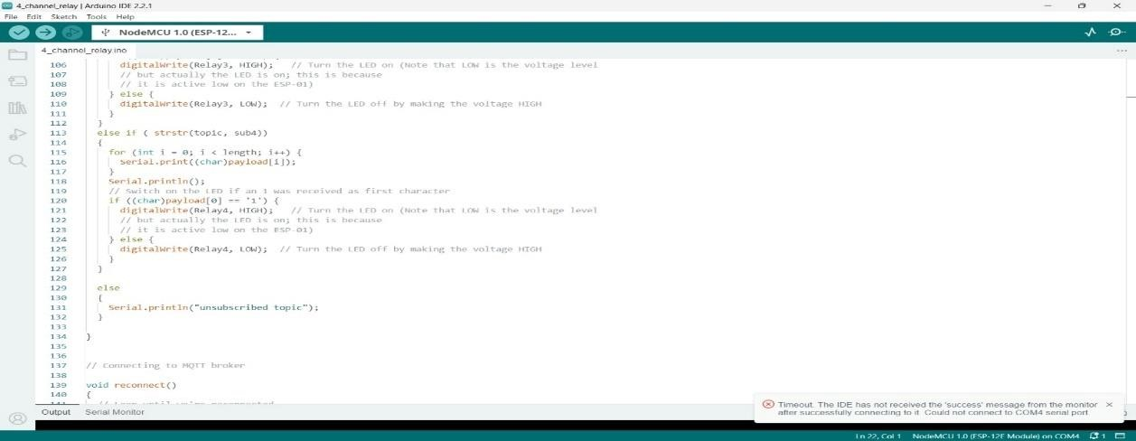

*Figure 68 : Wi-Fi controlled 4 channel relay Arduino code 04*

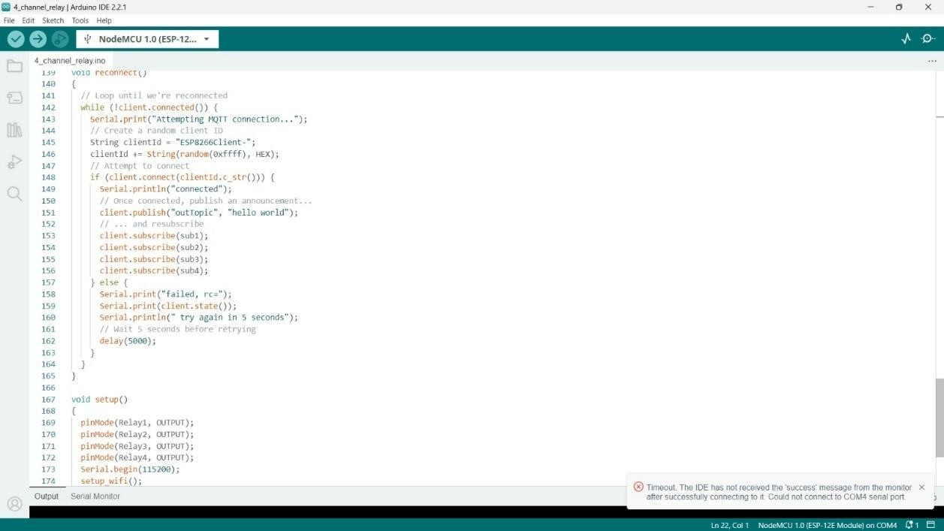

*Figure 69 : Wi-Fi controlled 4 channel relay Arduino code 05*

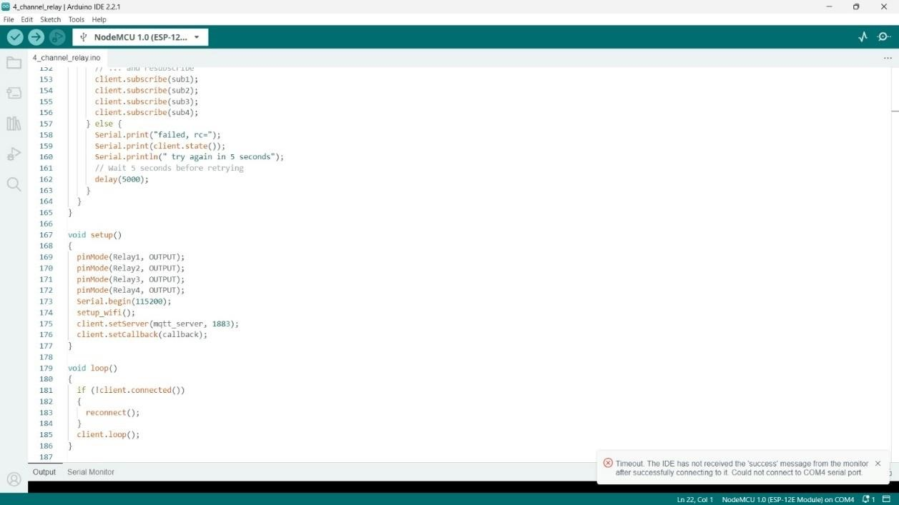

*Figure 70 : Wi-Fi controlled 4 channel relay Arduino code 06*

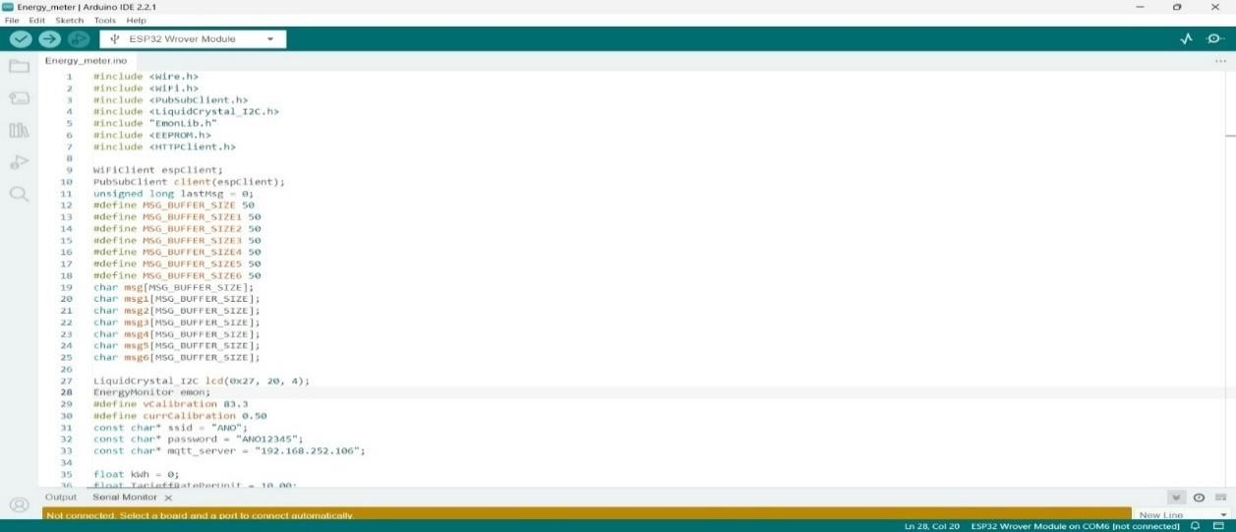

*Figure 71 : Energy meter Arduino code 01*

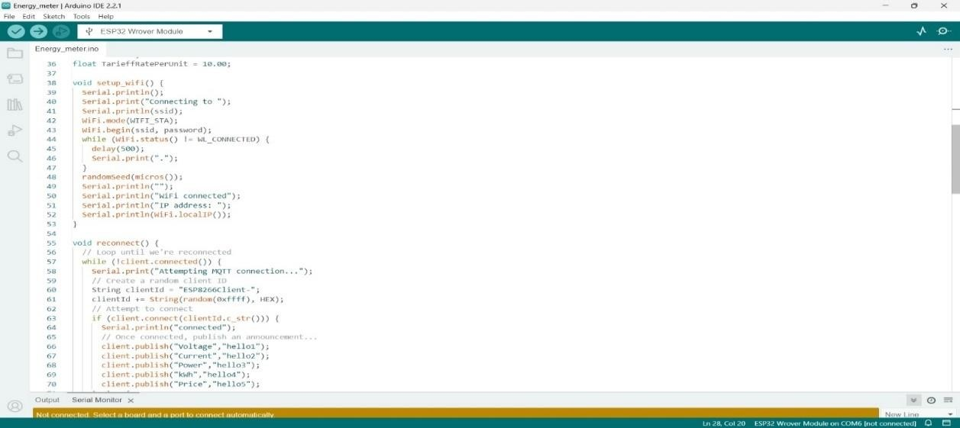

*Figure 72 : Energy meter Arduino code 02*

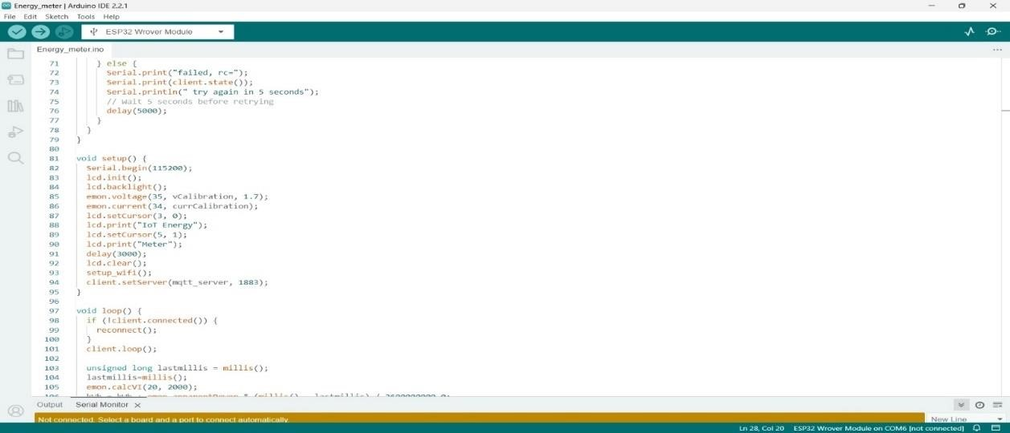

*Figure 73 : Energy meter Arduino code 03*

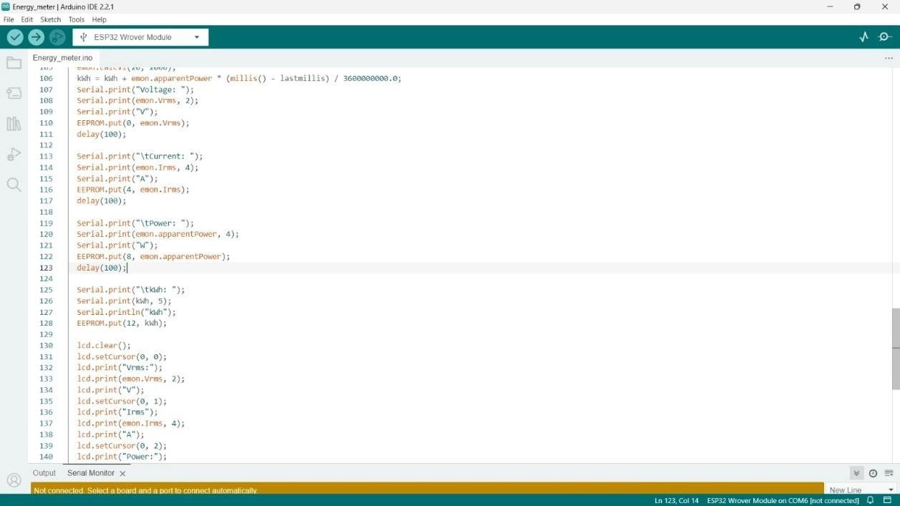

*Figure 74 : Energy meter Arduino code 04*

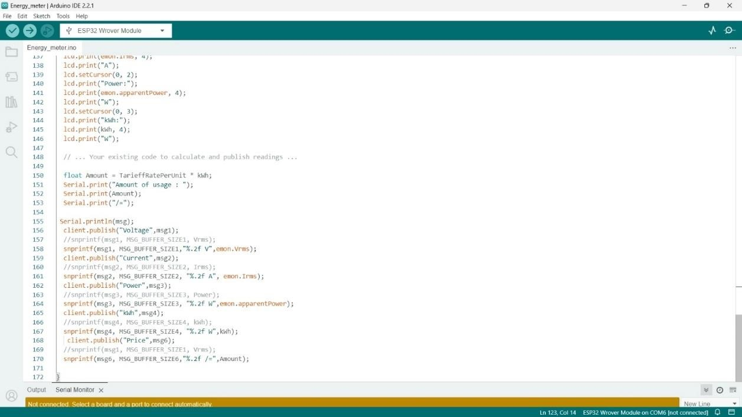

*Figure 75 : Energy meter Arduino code 05*

#### Appendix C– Dashboard node red

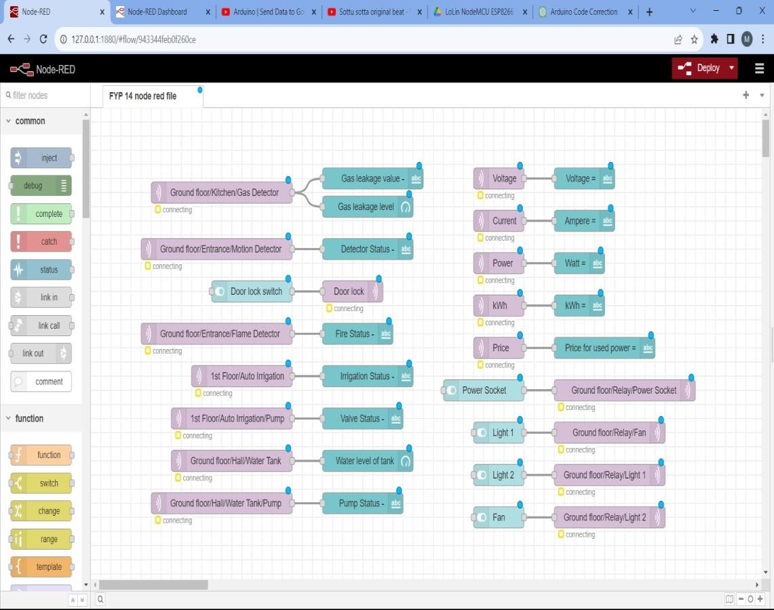

*Figure 76 : NODE RED WEB INTERFACE*

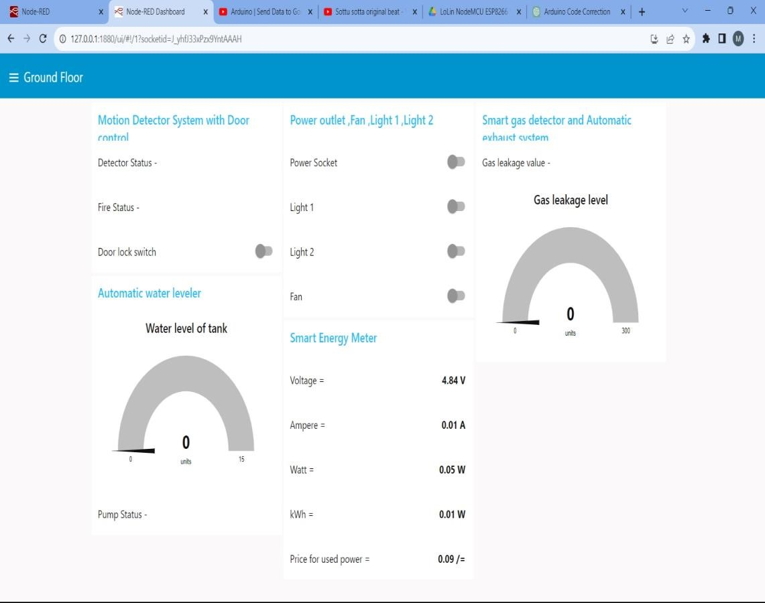

*Figure 77 : NODERED DASHBOARD*

#### Appendix D –Specifications

Table 1: Specifications of Solenoid Valve

|  |  |
| --- | --- |
| Voltage | 12V DC |
| Rated Power | 5W |
| Operation model | Normally closed (N/C) |
| Pressure | 0.02 – 0.8Mpa |
| Port size | G ¾'' |
| Fluid temperature | 0-100 degrees Celsius |
| Usage | water and low viscosity fluids |
| Flow characteristics | :0.02Mpa>2L/min;  0.10Mpa>10L/min;  0.30Mpa>16L/min;  0.80Mpa>28L/min |

*Table 2 : Specification of Ultrasonic Sensor*

|  |  |
| --- | --- |
| Operating Voltage | 3.3V DC to 5V |
| Operating Current | 15mA |
| Operation | Normally closed (N/C) |
| Port size | G ¾'' |
| Fluid temperature | 0-100 degrees Celsius |
| Usage | water and low viscosity fluids |
| Flow characteristics | :0.02Mpa>2L/min;  0.10Mpa>10L/min;  0.30Mpa>16L/min;  0.80Mpa>28L/min |

*Table 3 : specification of ZMPT101B AC single phase voltage sensor*

|  |
| --- |
| 1.Voltage up to 250 volts can be measured |
| 2. Lightweight with on-board micro-precision voltage transformer |
| 3.High precision on-board op-amp circuit |
| 4.Operating temperature: 40ºC ~ + 70ºC |
| 5. Supply voltage 5 volts to 30 volts |

##### *Table 4 : specification pf SCT-013 current sensor*

|  |  |
| --- | --- |
| Input Current | 0-30A AC |
| Output Signal | DC 0-1 V |
| Non-linearity | 2-3 % |
| Build-in sampling resistance (RL): | 62 Ω |
| Turn Ratio | 1800:1 |
| Resistance Grade | Grade B |
| Work Temperature | -25 °C~+70 °C |
| Dielectric Strength (between shell and output): | 1000 V AC / 1 min 5 mA |

##### *Table 5 : specification of 12VDC Gear motor*

|  |  |
| --- | --- |
| Operating Voltage | 12V DC |
| Stall Current | 1.5A |
| Operation | Normally closed (N/C) |
| Overall Diameter | 25mm |
| No load shaft RPM | 120 RPM @ 12VDC |
| Usage | water and low viscosity fluids |
| No load current | ~70mA |

##### *Table 6: specification of soil moisture sensor*

|  |  |
| --- | --- |
| Voltage | 3.3V - 5V DC |
| Rated Power | 5W |
| Control IC | LM393 |
| Variable resister | 10K |
| Operating temperature | -40 to 60 Celsius |
| Usage | Find soil is moisture or not. |